Dynamic Price Prediction

Team Members:

Venkata Anil Kumar Thota (012525734)

Megha Rajam Rao (013709488)

Nandini Puppala(013752713)

Prathusha Koouri(013710658)

San José State University, San Jose

**Table of Contents**

**1. Project Description 3**

**2. Requirements 10**

**3. Knowledge discovery in databases (KDD) 12**

**4. Feature Engineering 16**

**5. High-Level Architecture Design 32**

**6. Data Flow Diagram & Component Level Design 33**

**7. Sequence or Workflow 34**

**8. Data Science Algorithms & Features Used 34**

**9. Interfaces Restful & Server-Side Design 44**

**10. Client-Side Design 48**

**11. Testing (Data Validation / nFold) 50**

**12. Model Deployment 52**

**13. High Performance Computing (HPC) 60**

**14. Documentation 62**

**15. Design Patterns Used 65**

**16. AutoML or Serverless AI 67**

**17. Data Engineering 69**

**18. Active Learning or Feedback loop 71**

**19. Interpretability of the Model 73**

**References 75**

# Project Description

Dynamic Price prediction is key to business success in online retail platforms [1]. The hypothetical business scenario involves building a dynamic price prediction engine to provide price suggestions to sellers using the Mercari re-selling app. The algorithmic approach aimed to leverage the power of deep learning and machine learning to efficiently extract insights from a massive pool of historical data provided by Mercari in Kaggle. Sellers using the platform will be greatly benefited if the prices of their used goods, ranging from almost new to damaged, can be suggested based on existing market data. The backend code in python used google collaboratory in the initial stages to explore, pre-process and wrangle data before model fitting in Google cloud platform (GCP). The frontend interface powered by Flask and deployed on Amazon Web Services (AWS) Elastic compute cloud (EC2), was to be accessed through web applications by subscribers of the Mercari re-commerce platform. The end product is a prediction engine with the capability to instantly suggest prices based on historical data and user input.

**1.1 Methodology**

The widely advocated cross-industry process for data mining (CRISP-DM) [2] approach was used to organize and design the analytics model.

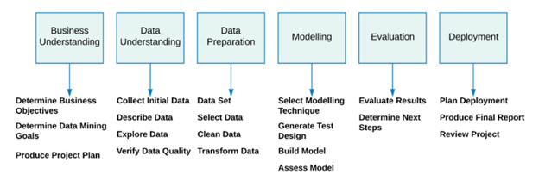

Fig 1.1. CRISP-DM approach for data analytics [2]

Figure 1.1 illustrates the major phases in this project. Business understanding phase involves determining the business objectives, data mining goals and project plan. Data understanding requires data collection, description of statistical attributes in data description before exploration and quality verification. Data preparation involved zeroing in on the data, selection and cleansing, before data transformation and validation. Succeeded by modelling phase, the various modelling approaches were selected before generating a test design, model before assessing the results. Evaluation phase necessitated result comparison and evaluation before determining the succeeding steps. We chose the model for deployment, which was built on Convoluted Neural network (CNN or ConvNet). The final deployment phase involved deploying the model in cloud platform, documentation and review.

**1.2 Concepts**

Price suggestion and optimization encompasses the essential step of market research and price setup [3]. This saves time, eliminates inconceivable prices and greatly improves ease of use for the customers. Ultimately, it will result in customer retention and satisfaction. The underlying concept of Dynamic pricing [4] , otherwise known as real-time pricing or repricing, is basically a study to determine the optimal prices for products or services, in a frequently adjustable framework. According to McKinsey & Company [5], a well-balanced dynamic pricing scheme typically yields a substantial growth of 2-5% in sales and 5-10% in margins.

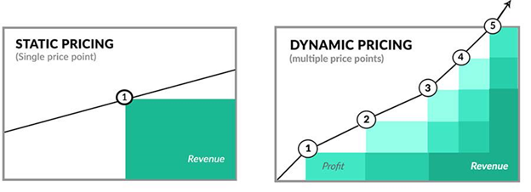

Fig 1.2. Static and dynamic pricing [6]

Figure 1.2 shows the differences between static and dynamic pricing model. Static pricing has a single price point and is heavily dependent on the revenue. Dynamic pricing is marked by multiple price points that fluctuate based on market conditions. The typical variables [7] are supply, demand, customer data, competition prices and substitute product prices that are fed to the machine learning algorithm. Business objectives such as profit and margin are prime variables. As shown in Figure 1.3, supply can be further subdivided into inventory cost and future cost, while customer data pertains to demographic data, device data and behavior data.

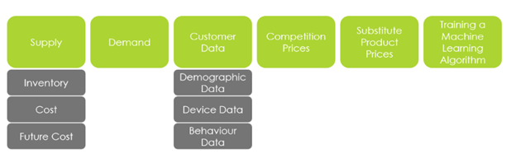

Fig 1.3. Typical variables in dynamic pricing model [7]

The machine learning approach can be supervised or unsupervised, that is with or without labeled data respectively. Clustering techniques help in categorizing and grouping customers into tiers while supervised techniques facilitate the creation of prediction models. Although Airline industry [6] served as trailblazers in dynamic pricing, Amazon took the pioneering stride with their revolutionary dynamic pricing scheme. Surge pricing from uber is yet another classic example of this scheme. Ultimately, it is a sign of fast-adapting business ventures, that thrive and succeed in the volatile online marketplace.

**1.3 Business scenario**

Mercari is a Japanese re-commerce app [8] where users resell items ranging from almost new to intensely used. They are basically a popular customer to customer (C2C) flea market app [8] as shown in figure 1.4. 74.1% smartphone [9] users in Japan used the platform in 2017, with 71 million [10] downloads and 10.5 million active users. It is available in Japan, United Kingdom (UK) and United States (US) [10]. Figure 1.5 shows the google play rank of the Mercari application (app) in the United states in the past one month. It is ranked at number 22 [11] among shopping applications available in the country.

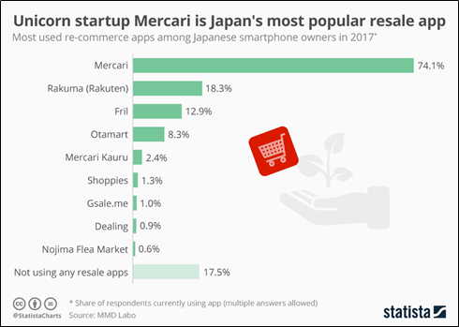

Fig 1.4. Statistics highlighting the popularity of Mercari [12]

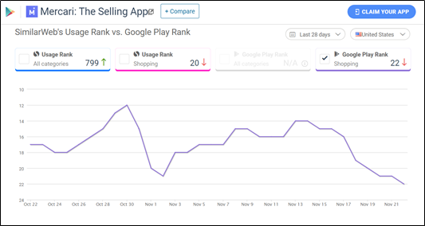

Fig 1.5. Monthly Google Play rank of Mercari in the United States [11]

Figure 1.6 cites some of the popular news mediums that cited Mercari. They are CNBC, TeenVogue, Brit+Co and Women’s Day. Women’s day recognized Mercari as the Top 15 money-making app in the US. Major US competitors [11] of Mercari are eBay, Postmark, letgo, Smiles and Offer up as illustrated in figure 1.7.

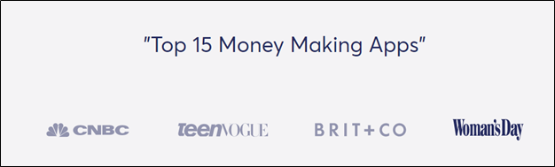

Fig 1.6. Popular news medium Women’s Day - opinion on Mercari [51]

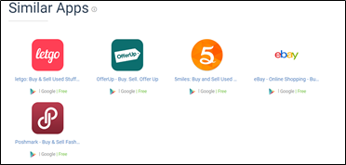

Fig 1.7. Business competitors [11]

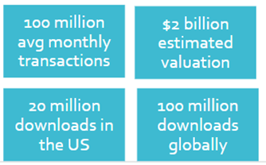

Fig 1.8. Statistics about Mercari [13]

Figure 1.8 shows some interesting statistics about Mercari. It has an average of 100 million transactions every month, with a total of over $2 billion estimated valuation. 20 million downloads in the US is a small chunk of their global standing at 100 million [13].

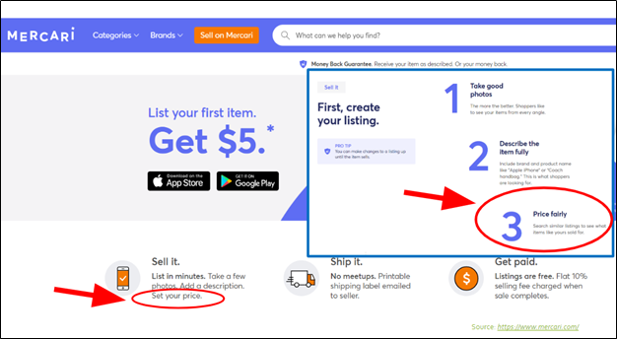

Fig 1.9. Mercari website [51]

Figure 1.9 is a screenshot from the web application of the platform. It emphasizes the importance of correct price setting for success in transactions. Sellers have to set optimal price, which is fair, competitive and at par with other sellers. Historical data provides similar listings and their prices. Businesses have to adapt and provide cost-effective solutions that rapidly adapt to changes in the market conditions. Their vision is customer retention and satisfaction, culminating in a wider customer base. More transactions and speedy sales form part of their typical mission. Suggestions will enable users to set the optimal prices and successfully sell their product.

# Requirements

The project envisioned to build a price prediction engine with the attributes cited in table 2.1 [52].

|  |  |
| --- | --- |
| Input | Item attributes such as description, category, brand and shipping based on available features |
| Input format | Text input and selection from drop box |
| Input schema | Button and pop-up Form |
| Output | Price in dollars |
| Output schema | Text with the price in dollars |
| Output format | Suggested Price for ‘*item_name’* is: $*xx.xx* |
| Language | English |
| Suggestion speed | Instant suggestion |
| Frontend | Interactive interface with buttons, forms and pop-ups. |
| Frontend background | Vibrant colors and graphics with Mercari logo |
| Programming language for coding | Python |
| Techniques | Natural Language Processing (NLP), Supervised Machine learning (ML) and Deep learning (DL) |
| Deployment framework | Flask application programming interface (API) |
| Markup languages | Hypertext Markup Language (HTML) and Cascading Style Sheets (CSS) |
| Implementation | Any cloud platform |
| Model input | Historical data of similar listings and prices |
| Environment for model fitting | Google colaboratory or Google cloud platform (GCP) |
| Runtime type | Graphics processing unit (GPU) & Tensor processing unit (TPU) in google colaboratory and GCP |
| Coding notebook | Jupyter notebook, Google colaboratory and Spyder |

Table 2.1: Requirements [52]

# Knowledge discovery in databases (KDD)

The Knowledge discovery in databases (KDD) process is illustrated in figure 3.1.

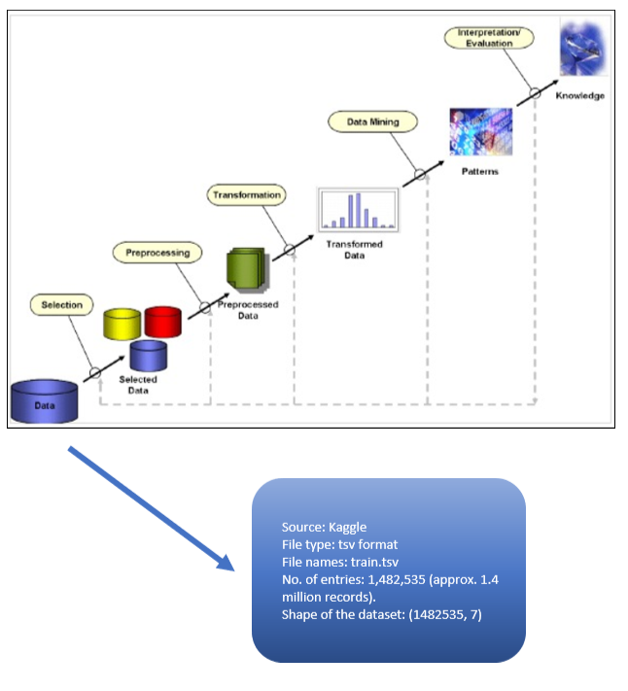

Fig 3.1. KDD Process [53]

Data from a data source is selected, pre-processed and transformation and statistical analysis is performed before visualization. Patterns observed are evaluated and interpreted for useful insights.

1. **Data Selection:** Data from Kaggle in tab-separated values (TSV) format is ingested by the system. Approximately 1.4 million records in 7 columns are provided as the input [54].
2. **Data Pre-processing**: Imputed nearly 14% of the null values in description, brand name and category. The values were imputed based on the existing values. Stopwords, newlines and punctuation marks were omitted in this step before the remaining words were converted to lowercase.
3. **Data Transformation:** Forthcoming data transformation chapter clearly explains the process of data transformation. NLP techniques such as word2vec facilitated the vectorization of words and generation of word embeddings. Name and description columns were transformed using this method. Name and description further underwent dimensionality reduction using Principal component analysis (PCA). Brand name, category and subcategory, which were incremental groups of category, were label encoded. Finally, the data was standardized using Standard scaler. Target value which is price, was converted to logarithmic format as it was right-skewed.
4. **Data mining:** Patterns unearthed from exploratory data analysis (EDA) are explained in the succeeding sections. They were visualized using matplotlib and seaborn packages. Statistical study was performed to reveal vital statistical attributes with the potential to serve as input attributes. As an experiment, Term-frequency Inverse document frequency (TF-IDF) was used to determine the importance of the words in the corpus. However, the same was excluded from the final model.

|  |  |  |
| --- | --- | --- |
| **Features** | **Metadata** | **Type** |
| name | The Name of the product/listing | Text |
| item_description | The description of the product/listing | Text |
| category_name | Category of the product/listing | Categorical |
| brand_name | The brand of the product/listing | Categorical |
| Item_condition_id | The condition of the items given by the seller | Multi-class |
| shipping | It shows whether the shipping is paid by seller or buyer | Binary |

Table 3.1: Features

|  |  |  |
| --- | --- | --- |
| **Target** | **Metadata** | **Type** |
| price | The price that the item is sold for. Values are mentioned in Dollars. This column doesn’t exist in test data since this column is the target variable. | Numeric |

Table 3.2: Target

1. **Interpretation/Evaluation:** As shown in table 3.1, name and item description are textual features, whereas category and brand name are categorical features. Item condition id is multiclass ranging from 1 for ‘Like New’, 2 for ‘Good’, 3 for ‘Acceptable, 4 for ‘Used’ to 5 for ‘Damaged’. Shipping is 1 if the seller bears the cost of shipping, whereas 0 stands for customer absorbing the cost of shipping. Table 3.2 shows the lone target which is price. The data was converted to logarithmic format to encapsulate the relevant range without the outliers. Statistical features of the dataset were discovered to be useful for model ingestion. Please refer the forthcoming sections with details and screenshots.

# Feature Engineering

**4.1. Exploratory Data Analysis (EDA)**

EDA is one of the crucial steps in Data science that allows us to get valuable insights on the data.

* **Price**: As the Price is our target variable, the analysis was mainly focused on price and its relation to other attributes. From the below graph, it is clearly known that the distribution of price is right-skewed and the outliers might affect the model.

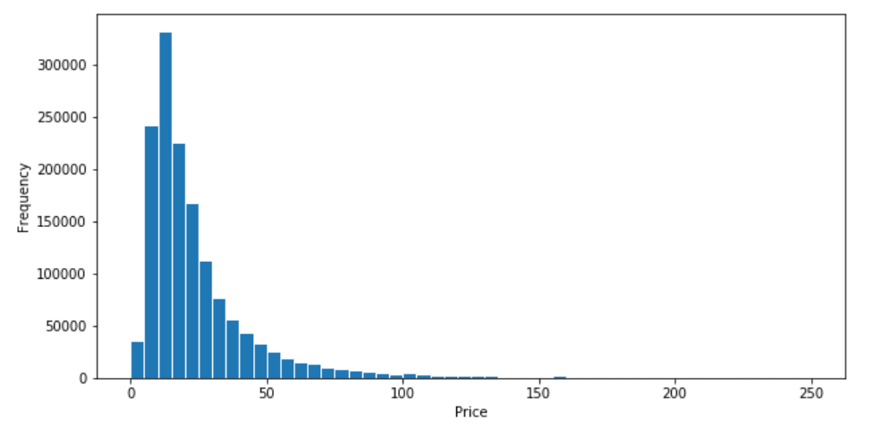

Fig 4.1. Price Distribution in data

Observations from the statistics in figure 4.1 are as follows.

* The median price is 17 dollars.
* Nearly 95% of the items have a price of 100 dollars or less.
* The distribution of price is heavily right-skewed.
* To nullify the effect of outliers, we explored the option of using log-transformed price.

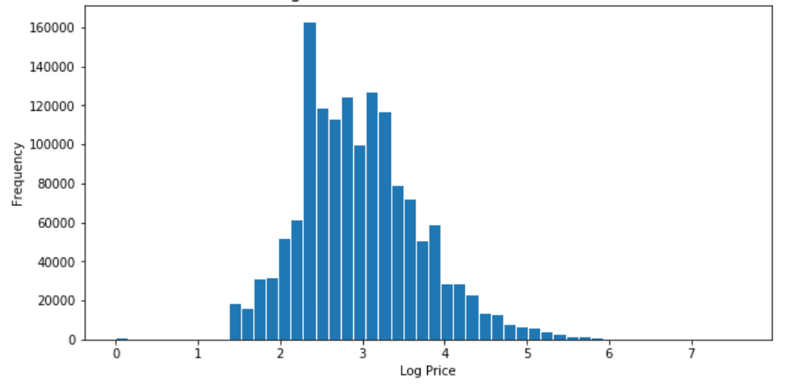

Fig 4.2. Log Transformed price distribution of the data

The price varies over a range of $2009 with a mean value of $26.7. This huge price range variation brings in a lot of outliers. To reduce the effect of outliers on price, we transformed the price to its log values, as shown in figure 4.2. Further, we added 1 to the variable before transformation to avoid zero and negative values.

* **Shipping:** Shipping ID is 1 if the shipping fee is paid by the seller and 0 if paid by buyer. From the graph, the shipping cost is split by users and sellers. Only 45% of the time the shipping cost is paid by sellers.

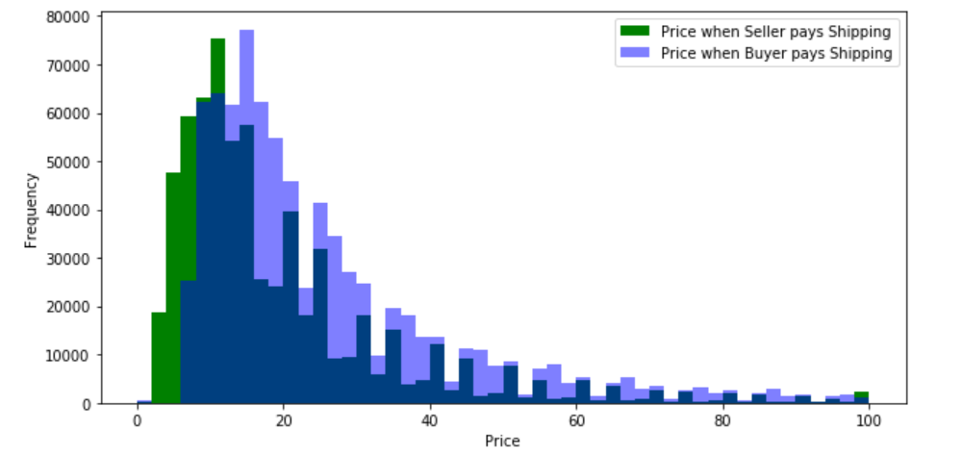

Fig 4.3. Price Distribution differentiated by Shipping type

From the graph in figure 4.3, we could infer that the average price paid by users, who had to pay for shipping fees were higher than those that did not pay for shipping costs. In contrast to our general perception, the seller may have to pay for some extra amount if it's shipped by buyer.

Also, we mapped the log transformed price distribution for both the shipping categories to check the consistency between the price and log transformed price as shown in figure 4.4.

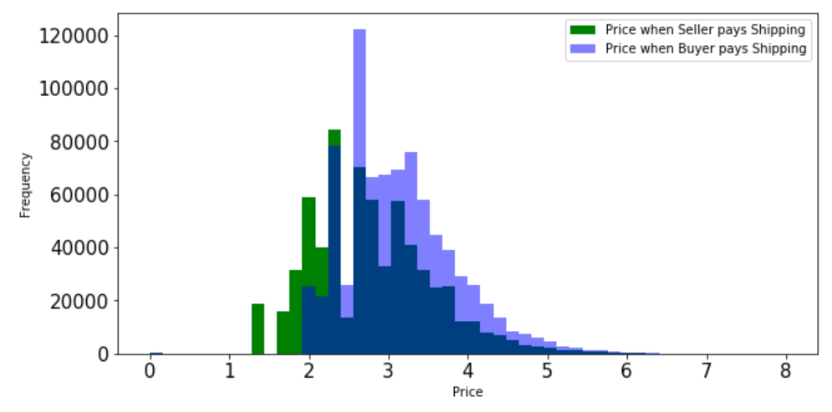

Fig 4.4. Log Price Distribution for both the shipping types

* **Condition ID:** The distribution of price with the variation in item conditions is further explored.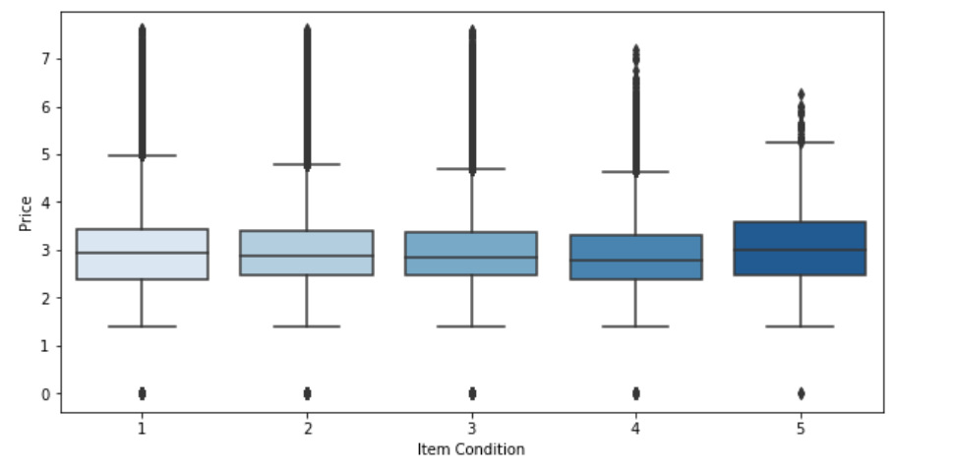

Fig 4.5. Price distribution for each condition_id

Observations from figure 4.5 are as follows:

* 43% of the items have item condition ID as 1 (best), while only 0.16% of the items have item condition ID 5.
* Interestingly, items with item condition ID 5 have higher median price compared to the items having better conditions.
* On further analysis, we found that items frequently sold with item condition id 5 are costly items such as gold chains and electronics, that can be used as spare parts.
* Furthermore, we analysed the some of the most frequently posted categories and visualized the same using a bar graph. The number of items were plotted against the frequency of items.

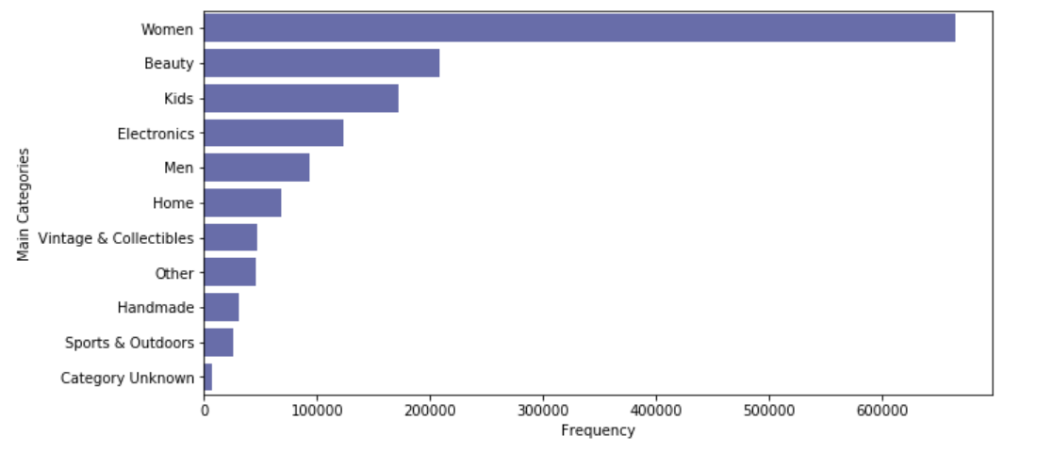

Fig 4.6. Frequency of main category items

Observations from figure 4.6 are as follows:

* Items under the category women holds the largest share on Mercari website with 44.84% posts.
* It is succeeded by the category Beauty with a share of 14.02% on the Mercari website.
* In total, there are eleven main categories, with Women and Beauty being the most popular ones, followed by Kids and electronics.
* Categories with highest revenue are as follows.

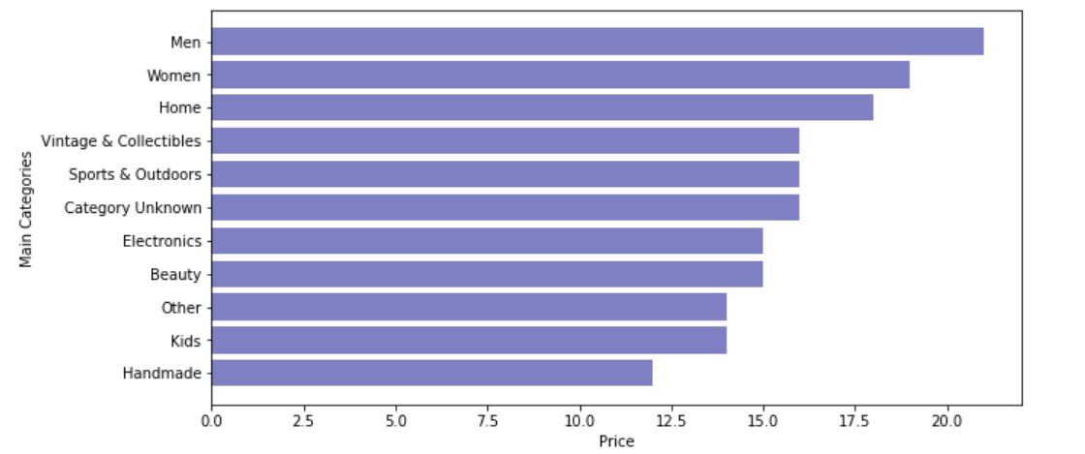

Fig 4.7. Categories sorted by median price

Although the products under category Women were the most popular ones (from figure 4.6), the products from category Men had the highest median price of 21 dollars (from figure 4.7), closely followed by the items from category Women with a median price of 19 dollars. Category named Handmade had the lowest median price of 12 dollars.

* **First subcategorization:**

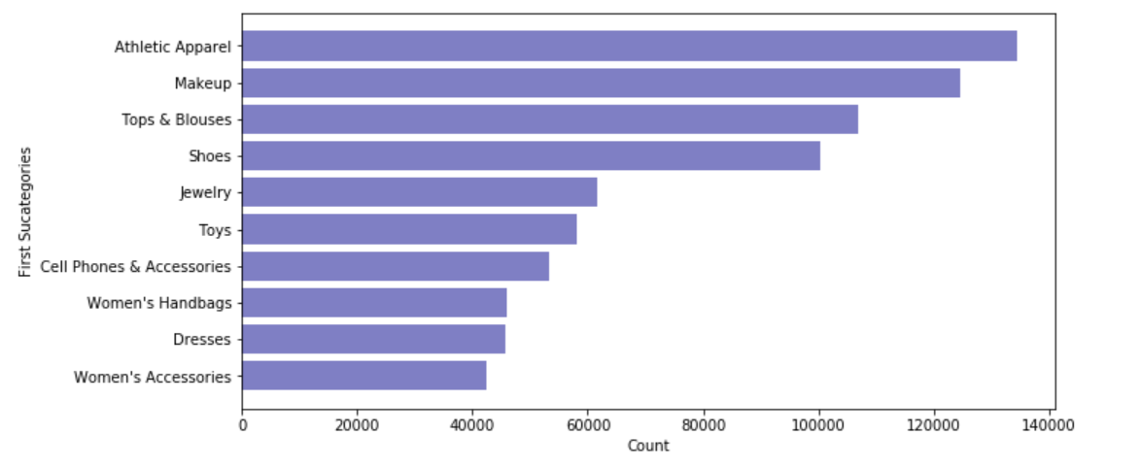

Fig 4.8. Top 10 most popular subcategories

Athletics apparel turns out to be the most popular subcategory as illustrated in figure 4.8. It is one of the most common sub-categories as it can be purchased under 2 main Categories, which are Men and Women.

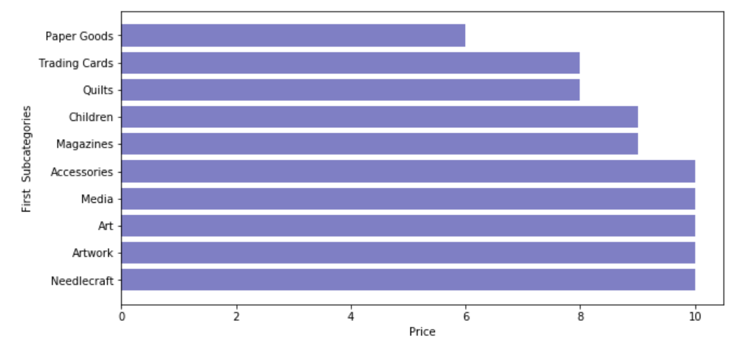

Fig 4.9. Bottom 10 from first subcategorization, sorted by price

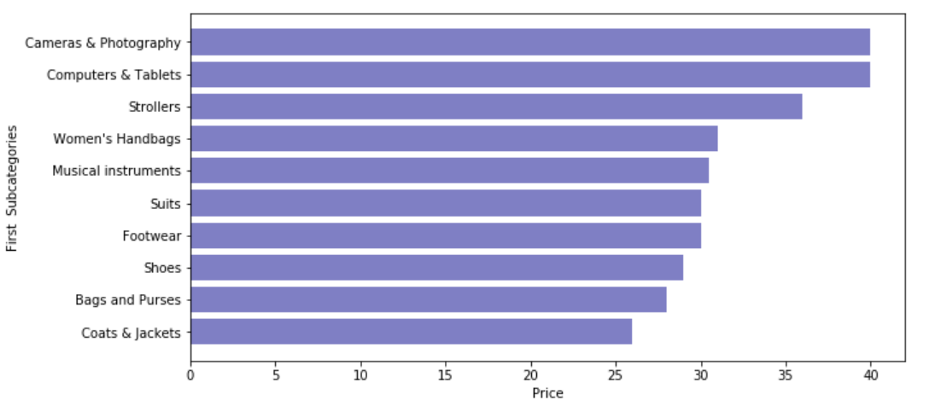

Fig 4.10. Top 10 from first subcategorization, sorted by price

Observations from the above three graphs:

* 9% of the total products come under Athletic Apparel sub-category.
* The median price view gave us an idea of the list of items that had higher median prices
* The items from the subcategory 'Computers & Tablets' had the highest median price of 40 dollars.
* The items from the subcategory 'Paper Goods' had the lowest median price of 6 dollars.
* **Second subcategorization:**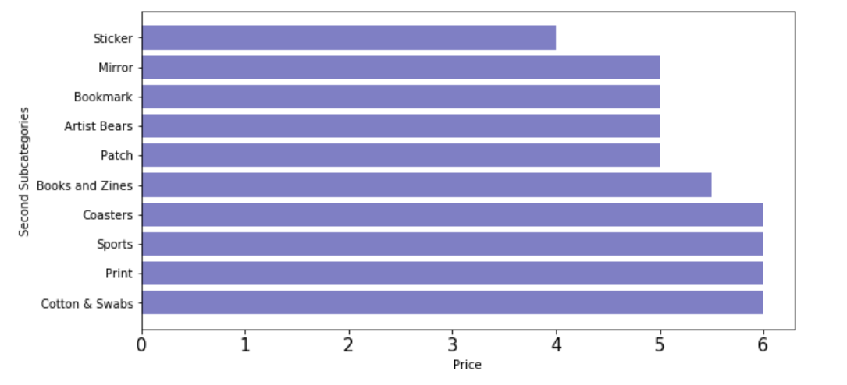

Fig 4.11. The top 10 second Subcategorization sorted by price.

Observations from the above three graphs:

* From figure 4.11, we could infer that 'Cotton and Swab' subcategory had the highest median price, with 6 dollars.
* The items from the subcategory 'Stickers' had the lowest median price of 4 dollars.
* **Brand Names:**

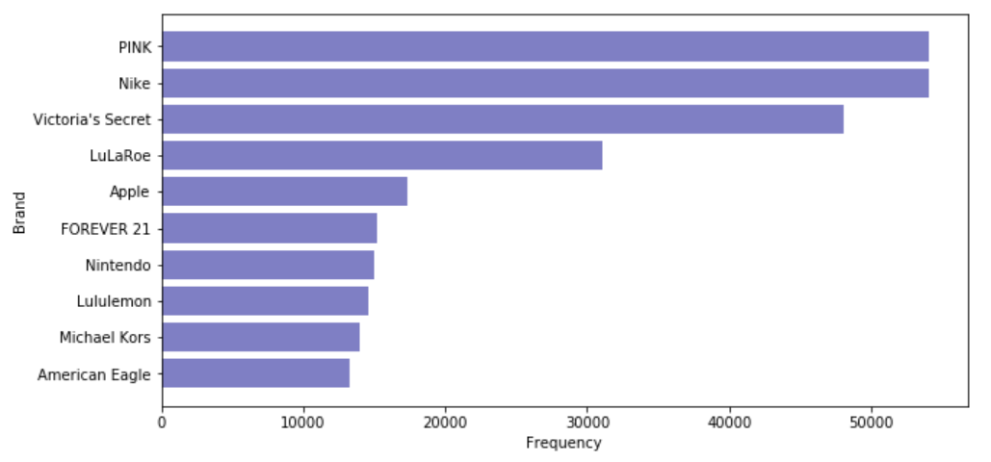

Fig 4.12. Top 10 most popular brands

According to figure 4.12, Nike and Victoria’s Secret are the most popular brands.

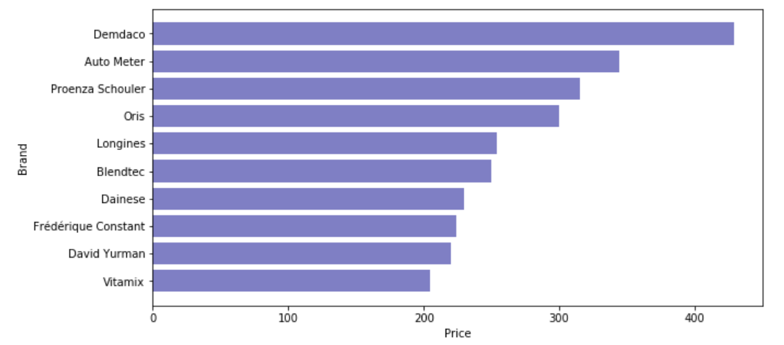

Fig 4.13. Top 10 brands sorted by median price

According to figure 4.13, Demdaco and Auto Meter are the brands with the highest prices.

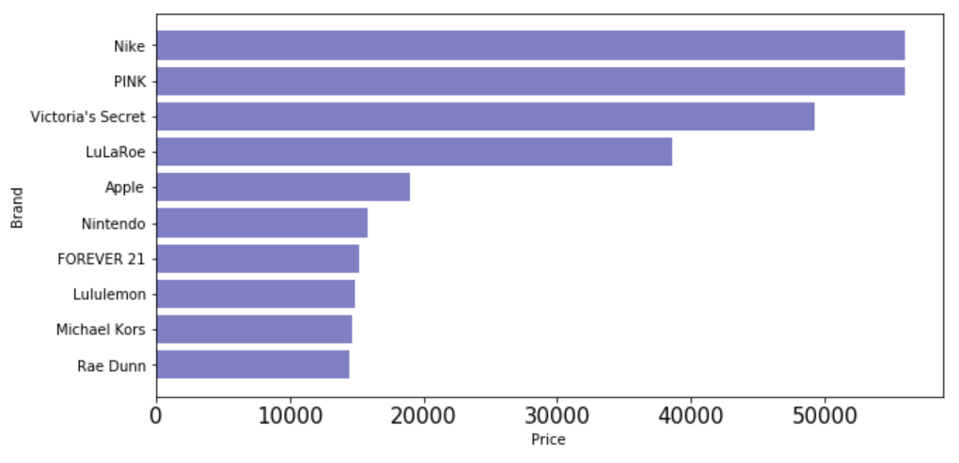

Fig 4.14. Top 10 most popular brands post filling null brand**s**

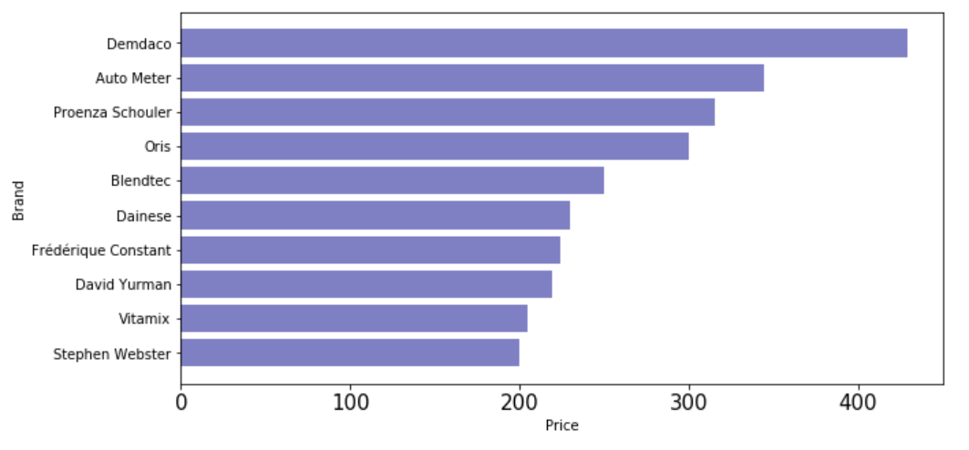

Fig 4.15. The top 10 brands after filling null brand sorted by median price

Comparing the most frequently sold brands and highly priced brands, specifically before and after filling in null brand values, we obtained similar results as shown in figure 4.14 and 4.15.

* **Pearson correlation:**

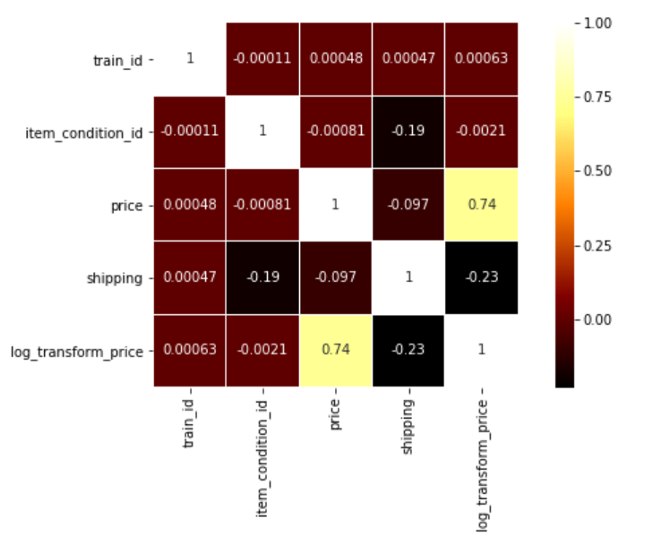

Fig 4.16. Pearson correlation heatmap

From the above correlation graph (Figure 4.16), we could infer that price and log prices are highly correlated as is expected.

From all the above graphs we could infer that the Data is quite clean, except for the null values and brand columns. We explained in detail about the transformations applied on these columns to make the consistent.

**4.2 Data Preprocessing**

Figure 4.17 is the flow diagram of the Data Preprocessing.

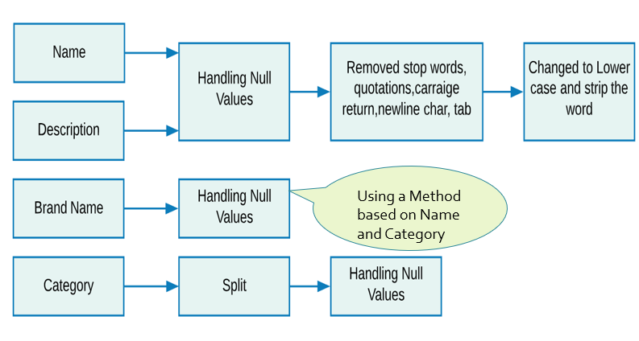

Fig 4.17. Data Preprocessing

After doing EDA on data, we gained a basic understanding on the data types and distribution of

data. With that knowledge we tried to impute null values for columns: Name, Description, Brand

Names and Category.

As per the raw data for Name and Description, name has no null values but description has cells with 4 null values which we replaced with ‘No description yet’. However, on further analysis we found 82000 rows with the value “No description yet” and one row from name, with value as ‘No name’. Hence, we can observe that description and name column are empty at times, as expected in raw data. After imputing null values in natural language data, we processed it further. The step included tokenization, removing stop words, decontraction of contracted words and removing quotations, carriage return, newline, and so on. Thereafter, we changed all the tokens to lowercase and stripped the extra spaces. Filtered and cleaned tokens were the final output.

The highest number of null values were in the field brand name, with nearly 630,000 null values, which is half of the data. After further analysis, we found few of the brand names in item name. Hence, we created a function to fill brand names based on name and category columns. Below are the steps.

**Step 1:** In the function, we created a dictionary of brand names as key, and list of categories as value, where the brand name is not null.

**Step 2:** Then, we sorted the dictionary in the order of increasing length of key and eliminated the brand names having a size less than 3.

**Step 3:** Then, we created a 2-dimensional (2D) array containing category and name, where the brand name is null. So, the length of array is same as the number of null values in brand names.

**Step 4:** Here, we iterate through brands in the created dictionary to search for the brand name in name, and category in the list of categories under that brand. Finally, return the brand name to be replaced for null value.

Using this approach, we could fill approximately 87,000 brand names which will improve the efficacy of the model.

There are about 6000 values in the category column, which are null values. From data analysis, we found 3 values separated by forward slash in category, which means they have subcategories. So, using split function we further divided the category column into 3, which are Main Category, Sub Category1 and Sub Category2. Thereafter, we filled the null values with ‘category_unknown’ for all the 3 columns.

**4.3 Data Transformation**

Figure 4.18 shows the flow diagram of Data Transformation.

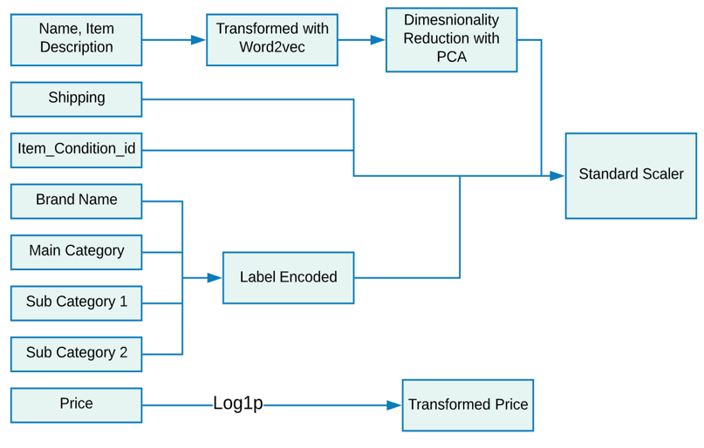

Fig 4.18. Data Transformation Flow Chart

After EDA and data pre-processing, we transformed the data. This step is done for better

prediction on test data. Sending clean data to the appropriate model will yield better results when predicting on Test Data. After pre-processing and filling null values, we have a total of 9 columns including target variable.

Initially, we transformed the target variable (Price) to its logarithmic format. From EDA in figure 4.2, data is evidently right-skewed. We transformed the same into a normal Distribution for better prediction accuracy.Further, log transformation reduces the effect of outliers. These are the 2 reasons for converting the Price to its logarithmic format.

Name and Description, which are natural language-based, needed extensive processing and transformation before model ingestion. After preprocessing these 2 columns, we have cleaned description and name column with word tokens. In order to use them as features, we analyzed and experimented with the 3 most popular approaches [14], which are basically language models in NLP.

* **Countvectorizer:** An easy method to convert the text (words/tokens) into vectors. Here, we take the array of unique words and fill with 0 if the word is not present, else 1. If the word has occurred more than once in the same row increase the value accordingly. For each row of data, we will have a long list of word count for the Name and Description, which are used as features in the prediction.
* **TF-IDF:** stands for ‘Term Frequency-Inverse Document Frequency’. TF is the number of times a word appears in the sentence. IDF is the natural logarithm of the total count of documents divided by the number of documents in which the word appears. It is superior as it considers the importance of words in the corpus of sentences and reduce the weightage if the word is more frequently used. The vector size will be the same as count vectorizer. However, the frequency/value for each word will change according to the importance of the word in the corpus of sentences.
* **Word2Vec Models**: It is a neural network model that represents a word in a vector space. It consists of single input, hidden and output layer. The output is a word vector. It understands the word based on its context as well as the relationship between other words in the corpus. This is due to its arrangement of similar words together and dissimilar words far apart in the vector space. Word2Vec has 2 types of model.
* **Continuous Bag of Words (CBOW)**: The neural network(NN) model has a sliding window approach. It considers the same number of words to left and right and predicts the center word.
* **Skip-grams** This NN model takes the input word and predicts the surrounding words.

In our case, we used CBOW model with a default window size of 5. Thereafter, we changed the vector length to 350 and 250 for description and name respectively, as 10:1000 is the recommended ratio of vector length to vocabulary size. The vocabulary sizes are approximately 35000 and 25000 for description and name respectively.

With TF-IDF and CountVectorizer, we had memory issues as the data is huge. Hence, we decided to use Word2Vec Model for language columns. Thereafter, we applied a dimensionality reduction technique to reduce the size of data. We used Principal component Analysis (PCA) [15], which reduced the dimensionality by removing and combining the correlated variables. This retained the maximum variance in data. It uses the approach of transforming the features to new set of variables called Principal Components which are perpendicular to each other in the space, and are sorted in descending order with the amount of variance captured from original features. PCA needs input in the standardized form. Hence, we applied standard scalar on our data to get better predictions. We captured almost 90 percent of variance by taking 120 components for description and 80 for name from the Word2Vec model [16].

Obviously, machines can only understand numbers. Hence, we Label Encoded the features such as Brand Name, Main Category, Sub Category 1 and Sub Category 2 to convert the categorical text data to numerical format which the model can understand and the label encoded data will have values like 0, 1, 2 etc. There is no relation between the different categories of data. But the model will interpret that the data has some relationship. It assumes that data is in some order which results in wrong prediction. To overcome such a false interpretation, we use one-hot encoding for the categorical data which divides one column data into multiple columns and helps improve model prediction. Before passing the data to the model, we used Standard scalar to standardize data with a mean of zero and standard deviation of one.

Derived features from description such as length of description (no. of words), acronyms percentage, log count of exclamation mark (!), asterisk (*), percentage symbol (%), remove marker ([rm]) and hashtags (#) are used to better understand the description feature.

Derived statistics from price are obtained by grouping brand name, category name and shipping, which are price_log_median, price_log_mean, price_log_standardDeviation, log count, log minimum and log maximum. Statistical analysis reveals trends and behavior of customers for pricing used stuff.

# High-Level Architecture Design

Figure 5.1 outlines the architectural design of our final model.

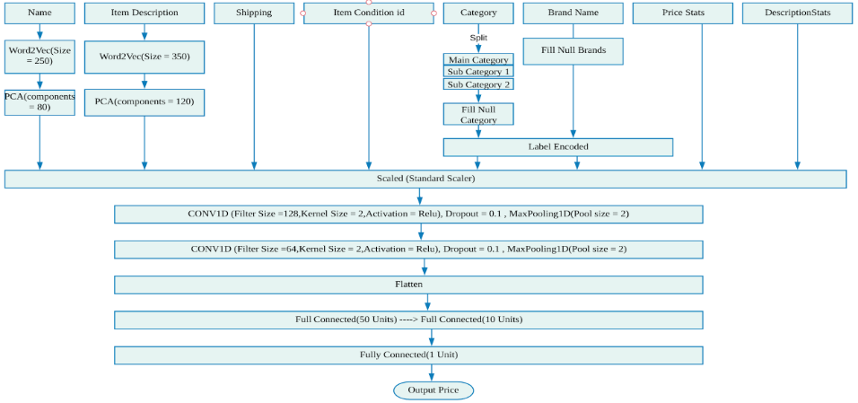

Fig 5.1. High Level Architecture Design

# Data Flow Diagram & Component Level Design

Figure 6.1 shows the Data Flow diagram of our system.

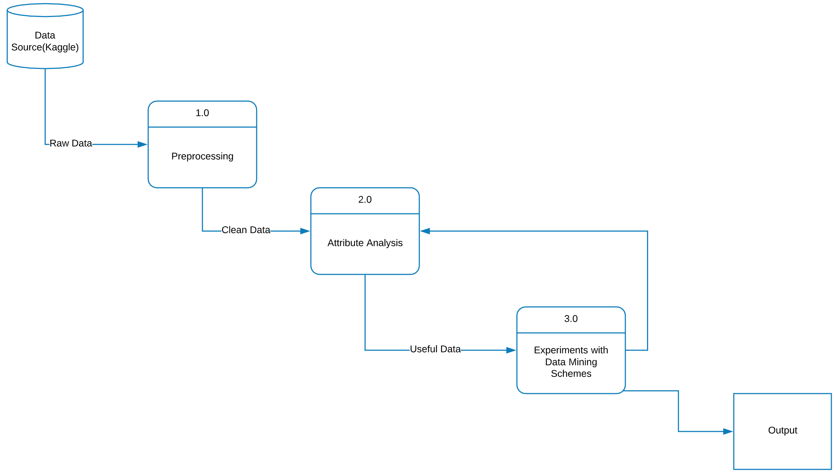

Fig 6.1. Data Flow Diagram

# Sequence or Workflow

Figure 7.1 outlines the workflow of our project.

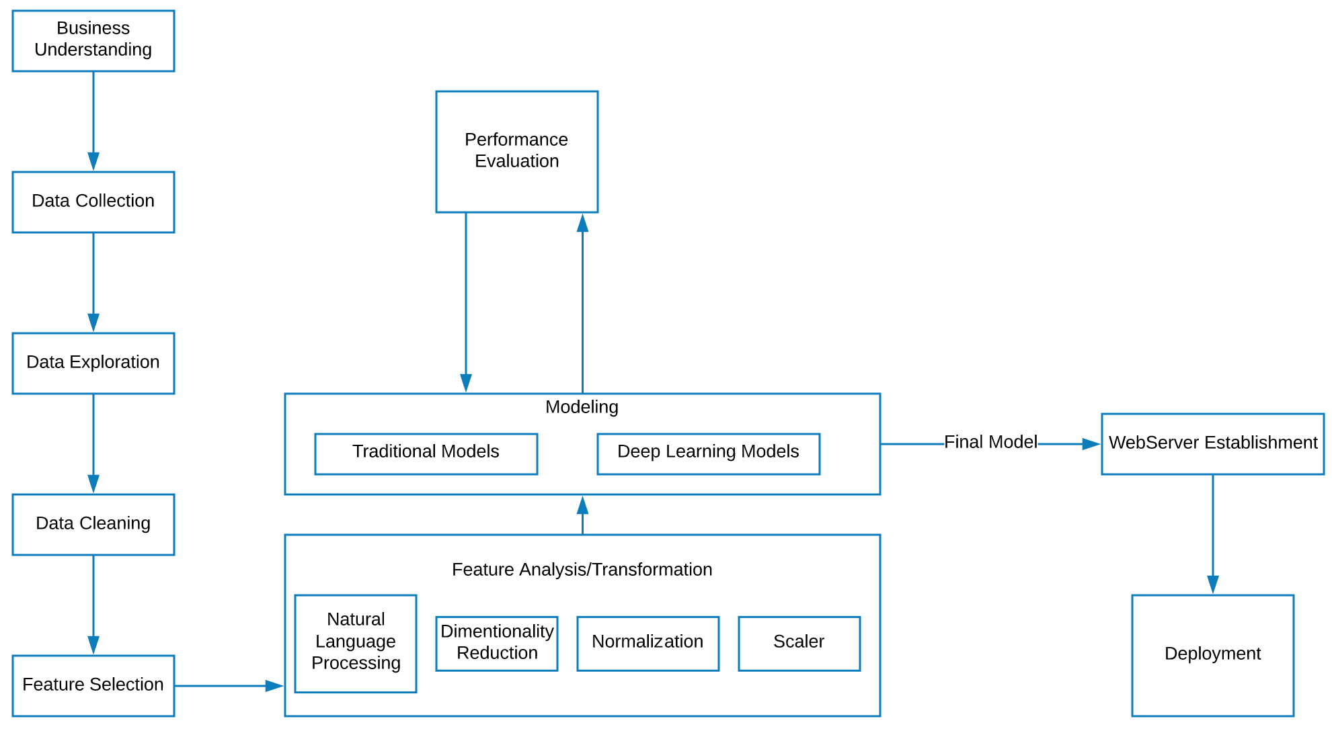

Fig 7.1. Workflow

# Data Science Algorithms & Features Used

**8.1 Traditional ML Algorithms**

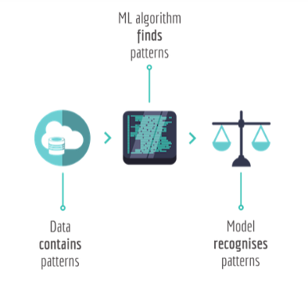

Fig 8.1. Model Fitting process [17]

In any machine learning project, the baseline experimentation has to be on traditional models and incrementally implement more complex models. We explored basic ML models followed by more complicated deep learning models. Below are the traditional ML algorithms [18]:

* **Linear regression:** Linear Regression is a baseline model for any Regression models. The target variable is a continuous variable. Hence we started with this model.

This regression technique finds a linear relationship between predictors(inputs) and target(output) variables. We used sci-kit learn library in python and fitted the model. We could get a value of 0.56 Root mean squared Logarithmic error (RMSLE) for linear regression.

* **Support Vectors Regressor (SVR):** SVR is a regression algorithm where we try to fit the error within a certain threshold. It is unlike simple regression algorithms where we try to minimize the error rate. In SVM regression, the input is first mapped onto an *m*-dimensional feature space using some fixed (nonlinear) mapping, and then a linear model is constructed in this feature space. We used scikit learn’s SVRregressor to build the model. We could get an improved RMSLE of 0.55.
* **Decision Tree:** Since tree-based algorithms are one of the best methods used for supervised learning algorithms, we tried the same. A decision tree can handle both numerical and categorical data. A decision tree algorithm uses a graph that resembles a tree. Each split is made based on the sum of squared errors in a regression tree.

Using a regression tree we could get an RMSLE of 0.58.

* **Extreme Gradient boosting (XGBoost):** There are various boosting techniques in practice which are giving very good results like Gradient boosting, XGboost and Adaboost. We chose XGboost as it is known to be efficient with huge data. Our dataset had over 1 million records, so we wanted to try this algorithm as well. We could get an RMSLE of 0.61 with this algorithm.
* **Random Forest:** Random Forest is one of the most popular ensemble techniques. It has emerged the winner in many data science competitions. It is a supervised Machine Learning algorithm which is built by picking up features randomly from the data and builds decision trees in making predictions on classification and regression problems. Since a forest is built on picking up features from the data. It is important to set how many features, it should pick randomly and how deep it should build the tree. We could get an RMSLE of 0.51 with Random Forest.

|  |  |
| --- | --- |
| Traditional Machine Learning Algorithm | RMSLE |
| Linear Regression | 0.56 |
| SVM | 0.55 |
| Decision Tree | 0.58 |
| XGBoost | 0.61 |
| Random Forest | 0.51 |

Table 8.1. Algorithms with RMSLE value

To improve the results, we explored more complicated models deep learning models.

**8.2. Deep Learning Algorithms**

From our research, we determined that using Deep learning models will improve the model performance as our data has Natural Language features.

The Deep learning(DL) algorithms use Artificial neural networks (ANN) [19] made of multiple artificial neurons. An ANN is a computing system that mimics biological neural network in the human brain. ANN can learn progressively and improve its performance over time. It consists of a network of nodes aka neurons which takes a numerical input. It transforms the input using a non-linear function applied on the sum of the inputs. The output from each neuron is then multiplied by a random weight which is adjusted based on the error in the network by back propagating through the whole network. The process is repeated to reduce the error and set the optimal weights.

There are multiple layers in the ANN [20], which are single input and output layers accompanied by one or more hidden layers. As the number of hidden layers increases, the depth and complexity of the network increases. Eventually, it will be hard to decipher the operations in the network once it gets deeper and more complex.

Apart from simple multilayer perceptron (MLP) model there are many other complex deep learning algorithms. We have experimented with Convolutional neural network (CNN or ConvNet) and LSTM (Long Short-Term Model), which is a type of Recurrent Neural Network (RNN).

CNN is well-known for image analysis and speed [21]. However, they can be used for both regression and classification studies. CNN detects patterns in the data so they are called pattern detectors. We use CONV1D for data analysis and CONV2D for image analysis. Convolution (CONV) layers differentiate CNN from simple MLP. The neurons in the convolution layer takes the input and transforms using convolution operation. Each convolution layer consists of specified number of filters that help identify patterns in the data. Each layer or filter can detect different types of patterns. Deeper networks detect sophisticated patterns and generate better predictions. Each filter is a matrix, usually called kernel, withf random weights. Each time the input is given to conv layer, the filter slides over it. This is known as convolving process. It calculates the dot product of filter(data) with the input, which identifies patterns in that layer. It is sent to the next layer to identify better patterns. Finally, these conv layers are connected to fully connected layers (ANN layer) to produce the final output.

Recurrent Neural Networks are designed to capture information for sequences or time series data [21]. They can take variable size inputs and give us variable size outputs. They work on recursive formula shown in figure 8.2. The new state of RNN (St) at time ‘t’ is a function of its old state (St-1) at time ‘t-1’ and the input (Xt) at time ‘t’. This formula is the basic idea behind RNN.

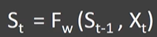

Fig 8.2. Recursive Formula [21]

Here, ‘t’ is one-time step. We repeat this for multiple time steps in time series data where the output is again fed to the input in the recursive manner in deep RNN. ANN learn through backpropagation but RNN learn by backpropagation through time. Each state in RNN is considered one time step. As the network gets deeper the gradient used for learning gets smaller and the network stops learning. This is called vanishing gradient problem. In order to solve this problem, LSTM was introduced. LSTM consists of 3 gates and one cell state, which are additional interactions not available in RNN. The 3 gates in LSTM are input gate, forget gate and output gate. The cell state is used to keep track of the things to be remembered. Following figure 8.3 and 8.4 provides the formulas for each gate with different weights and cell state.

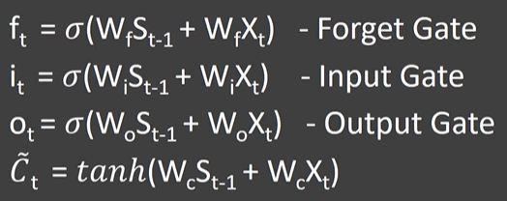

Fig 8.3. Different gates in LSTM [21]

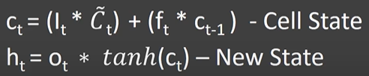

Fig 8.4. Calculation of Cell State [21]

By maintaining a cell state and having 3 different gates, we capture the required data and remove useless information. LSTM has better performance sequences and time series. It solves the vanishing gradient problem and performs better than RNN in terms of accuracy.

There are multiple applications of ANN, one among them is regression analysis. For our regression problem we have experimented with following Deep learning models:

1. Our first experiment uses simple MLP with only one input, hidden and output layer in the network also called Multilayer Perceptron model. The below figure 8.5 shows the model summary.

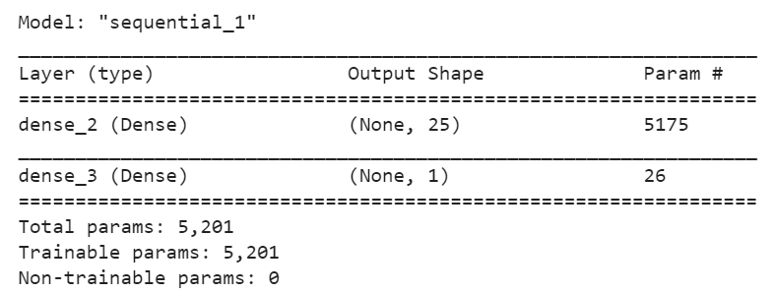

Fig 8.5. MLP with one hidden layer Model Summary

Though a small network, it performed better than traditional algorithms and give an RMSLE

score of 0.20.

1. The second network we selected has deeper layers which consists of 3 hidden layers. The performance improved as we achieved an RMSLE score of 0.19. We also included dropout layers with dropout ratio of 10% to reduce overfitting of model on training data. The model summary is given below.

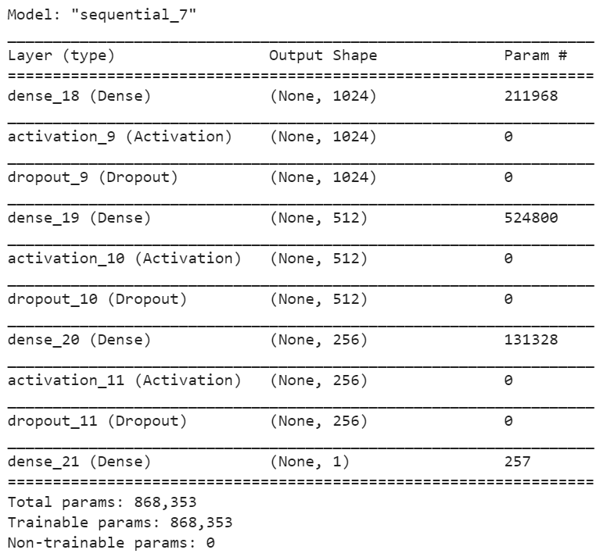

Fig 8.6. MLP with 3 hidden layers and Dropouts

1. Our next experiment was with LSTM as they are a good fit for text. In the network, we used 2 LSTM layers and one dense layer to produce output. As we had only one time step, the model underperformed and gave a higher RMSLE score compared to basic MLP. Hence, we rejected this model and continued with other deep learning models. The RMSLE value given by this model is 0.39. The model summary is given below.

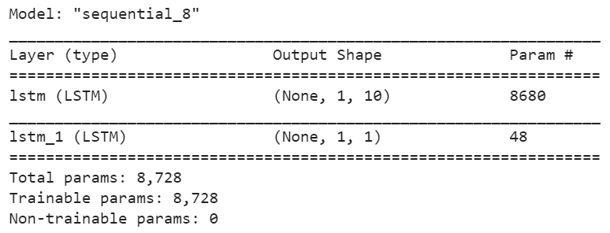

Fig 8.7. RNN model with LSTM cells.

1. The last attempted model was CNN, which turned out to be our final model. First, we started with a 3-layer network with one CONV layer having 64 filters and 2 dense (fully connected layers), which gave us the RMSLE value of 0.18. However, it was overfitting the data. Hence, we included dropout layers to reduce overfitting and also constructed a deeper conv network architecture to capture better patterns which can improve the prediction results further. Our final model consists of 2 CONV layers with 128 and 64 filters respectively. Thereafter, we used an intermediate flatten layer to convert the 3D output to 2D input, which is then fed to the dense(fully connected) layers. We also used max pooling layers such that we take the maximum value from the calculated dot product of convolution layer based on the grid size given in pooling layer. We used RELU (Rectified Linear Unit) as the non-linear activation function for final layer as it always gives positive values and is most used for regression problems. We have 3 dense layers. The final dense layer consists of 1 neuron which produces the final output, which is the predicted Price for this regression analysis. Number of training epochs are 10 and batch size is 128. These modifications improved the RMSLE value, which was finally at 0.16. CNN turned out to be a robust and fast model with lowest error value.

The input features used for our final model are as follows.

* Name 80 components
* Item description 120 components
* Shipping
* Item condition id
* Label Encoded (Main category, Sub category 1, Sub category 2 and Brand Names)
* Price and description statistics - 6 features each or 12 in total.

Below figure 8.8 is the summary of our final model.

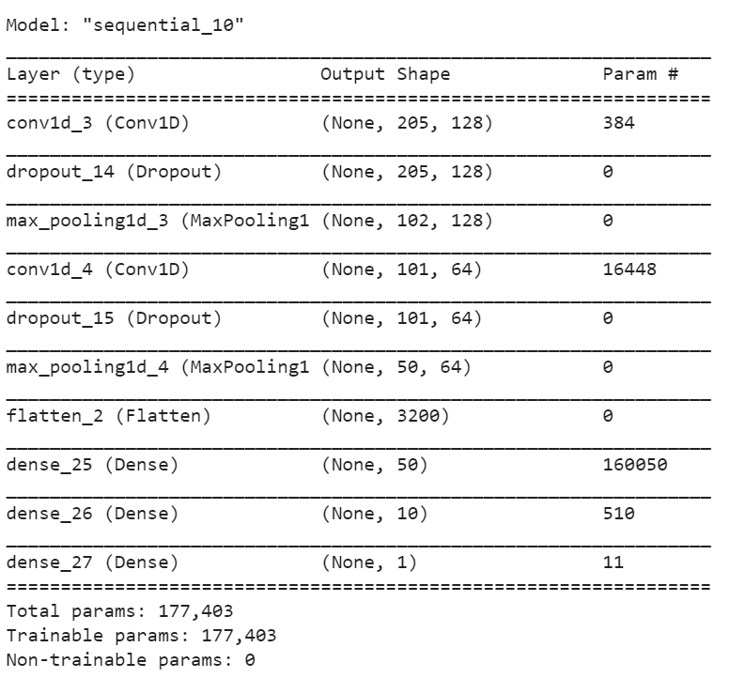

Fig 8.8. Final CNN Model Summary

# Interfaces Restful & Server-Side Design

An architectural design, where the data of a system is described in the form of a uniform resource locator (URL) is termed as representational state transfer (RESTful) web service. Hypertext Transfer Protocol (HTTP) is the communication protocol used for REST as it suits the architectural requirement of being a stateless communication [22]. Requests are sent to URLs by clients using the methods defined by the HTTP protocol. Some of the HTTP methods are [23]:

* GET
* POST
* PUT
* DELETE

There are many web development frameworks for Python. We preferred Flask as it is simple and powerful framework. It is a web framework which provides tools and technologies to build a web app [24].

Now let’s see how we created Flask API by integrating Machine learning model and client-side design. First, the flask package should be installed using ‘pip install flask’ in the command-line interface. Flask needs files to be in a specific layout in order to load and deploy into production [25]. Figure 9.1.illustrates the file structure of our project.

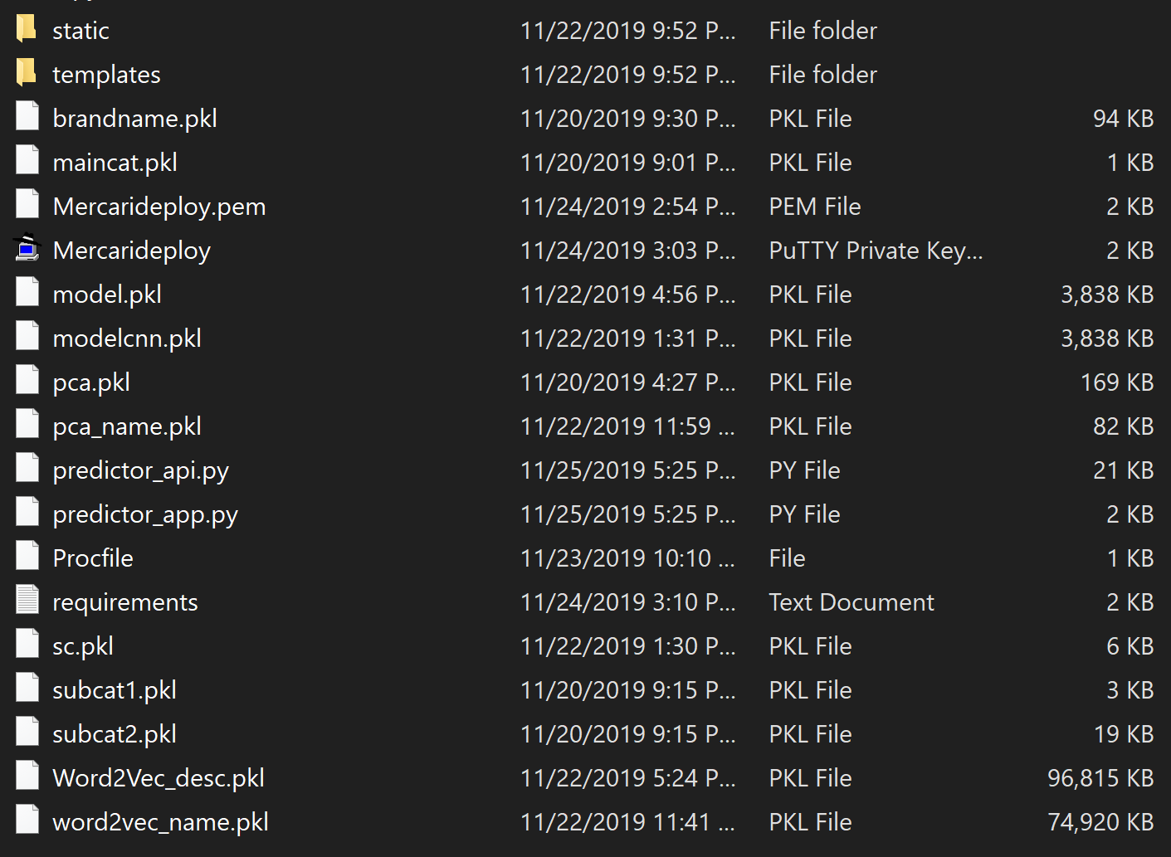

Fig 9.1. File Structure

* **Static:** This folder contains all the static assets like CSS files, images and fonts.
* **Template:** This is the folder in which HTML files are placed in order to render them using Flask.
* **predictor_api.py:** This file contains all the import statements for packages and pickle files of models. It also contains the functions that run our model and data preprocessing.
* **predictor_app.py:** This file contains the API which receives input from the user, calculates the predicted value and returns it.

The remaining part of the section explains the server-side design which is developed in ‘predictor_app.py’ file. All the other folder structures will be explained in the following sections.

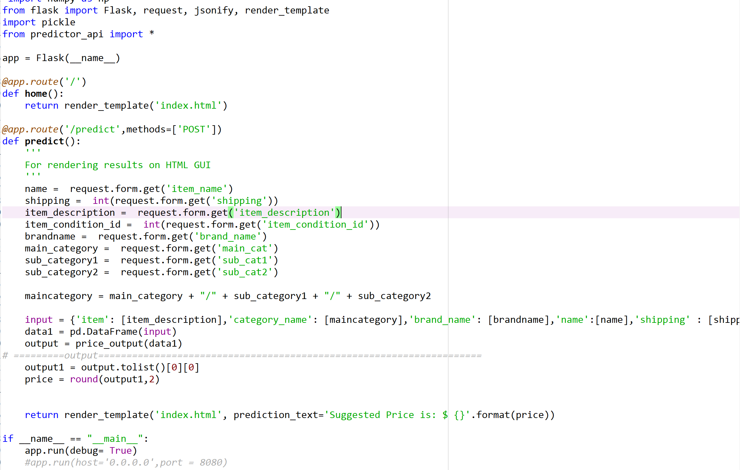

Fig 9.2. Snippet of predictor_app.py File

Different pieces of the code from figure 9.2. are described here. From flask package import the following:

* **Flask:** To create an Instance of flask.
* **request:** Object to access the incoming data to flask.
* **render_template:** Method to invoke the html file, which is in the templates folder.

Next, an instance of the flask class is created by using the code ‘app= Flask(__name__)’. In this case, as the application has a single module named ‘__name__’, it should be used as the argument for name [26]. Now ‘app’ object will act as central registry to view functions, URL and rendering templates. To bind the URL to a function, flask uses a decorator called route (). This will pass information about the URL to trigger our function. Soon after hitting the command ‘python predictor_app.py’, flask will render the template ‘index.html’, which is in the root directory. The line ‘@app.route(‘/predict’,methods[‘post’])’ tells flask what to do when the webpage loads [27]. Once the user submits the form on the webpage, post method will send form data to server. Now the predict function will be activated. This function will retrieve the values from the form using ‘request.form.get()’. Thereafter, it calculates the price by calling the method in ‘predictor_api.py’ file. Finally, it returns the predicted value to ‘index.html’ page. The last line (app.run(debug = True) of code is used to debug functions in the file.

# Client-Side Design

Client-Side is a way of designing the operation on the user's computer. It deals mostly with user interface. Hyper Text Markup Language (HTML) [28] and Cascading style sheets (CSS) [28] are used for developing user interface in our project. CSS files are stored in static folder whereas HTML files are stored in the templates folder.

HTML describes the structure of a webpage. It consists of a series of elements that helps to display content on the webpage. These elements are represented by tags. Relevant HTML tags used to make a webpage in our project are explained in Table. 10.1.

|  |  |
| --- | --- |
| **Tag** | **Functionality** |
| <html> | represents the root of document. |
| <title> | displays a title in the browser toolbar |
| <style> | include CSS file location here |
| <body> | defines document body |
| <h1> | to define most important heading |
| <form> | creates html form for user input |
| <label> | label for button, input, text area etc |
| <input> | input field where the user can enter the data |
| <option> | option in a selected list |
| <button> | clickable button |
| <p> | Defines a paragraph |
| <Select> | To create a dropdown list |
| <div> | Define a division or a section |

Table 10.1. Html Tags with their Functionality

Fig. 10.1. shows the code snippet of form method ‘POST’. It appends form data inside the body of HTTP and sends it as request post transaction.

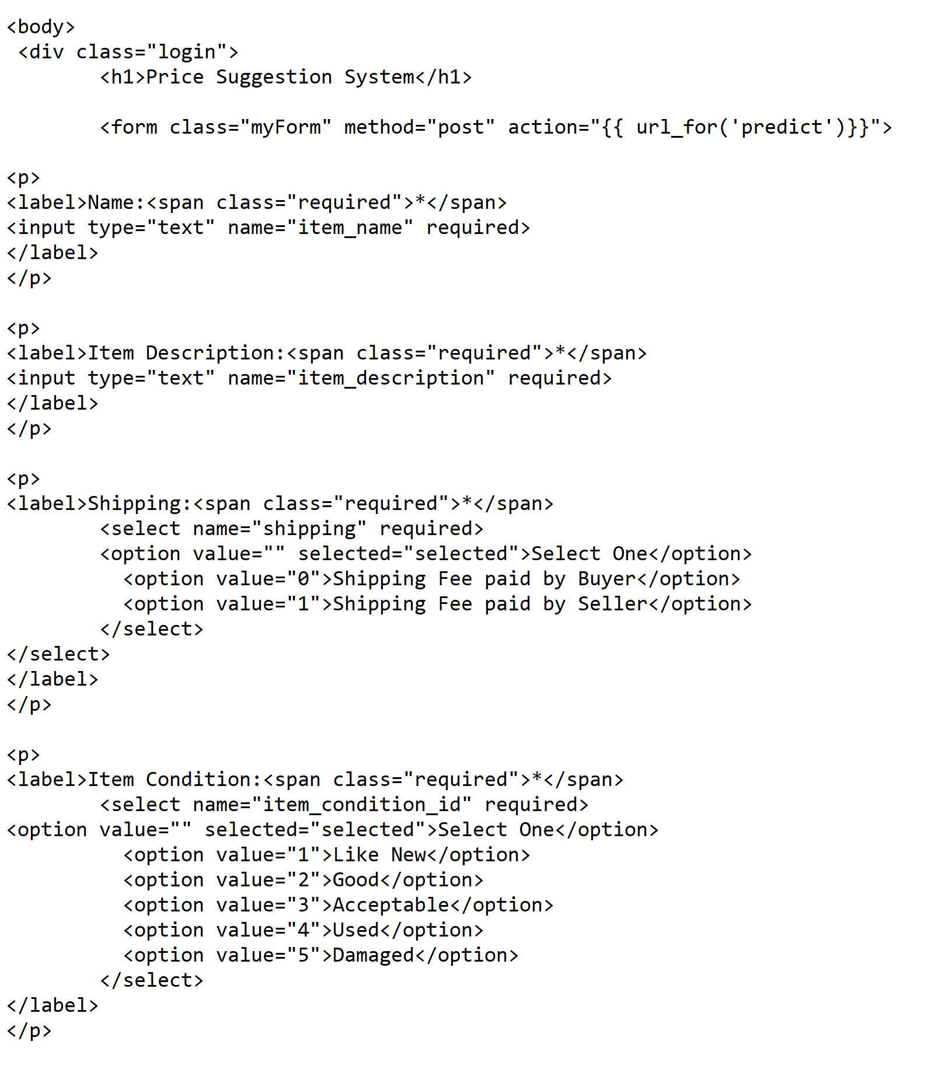

Fig. 10.1. Snippet of index.html File

Cascading Style Sheets (CSS) is a stylesheet language used for presentation of a document written in HTML. It describes how elements are rendered on screen. CSS is a combination of selector and declaration. A selector is an HTML tag and declarator is a composition of property and value. There are three different types of CSS [29]:

* Inline CSS
* External CSS
* Internal CSS

For inline CSS, every style element is included in HTML elements, whereas for internal CSS, it is specified in <head> section. For external CSS, we create a .css file and use in our HTML file as required. We adopted external CSS for our project. Table. 10.2 shows the CSS classes used in our project.

|  |  |
| --- | --- |
| **CSS Class** | **Functionality** |
| Box-sizing | to include the padding and border in an element’s width and height |
| Font-family | holds several font names |
| Font-size | size of the text |
| Padding | develops space around an element content inside defined borders |
| Border | specifies width and style to a border of an element |
| Width | width of an element |
| Text-align | to align inner content of a block element |
| Font-weight | specifies thick or thin characters in text |
| Margin-left | sets the Left margin of an element |
| Margin-top | sets the top margin of an element |
| Background | background effects of an element |

Table. 10.2. CSS Class with their Functionality

# Testing (Data Validation / nFold)

For Validating the results, we explored some of the widely used evaluation metrics in regression. They are Mean Squared Error (MSE), Mean Absolute Error (MAE) [30], Root Mean Squared Error (RMSE) and Root Mean Squared Logarithmic Error (RMSLE) [30]. The regression evaluation metric gives the output as an error term, which has a continuous rational number and there is no specific range for them. We evaluated these regression metrics. Smaller the error value, better is the model in analyzing newer data.

* **MSE:** Squared error loss is calculated by squaring the vertical distance between the predicted and actual point on graph. It gives the error for each data point. We can take the average of error values of all data points to find the final error term.
* **MAE:** measures the average magnitude of error among all the predictions. It considers the absolute difference between actual and predicted values and gives the average of them as output error.
* **RMSE:** is the square root of MSE.
* **RMSLE:** is the log form of RMSE. This is the final metric used in our project to evaluate the results.

Among all of them, we decided to proceed with RMSLE metric to evaluate the price for the following reasons:

* RMSLE mitigates the impact of outliers by nullifying their effect [31]. Hence it is robust. Other evaluation metrics such as MSE are prone to the effect of outliers and explodes the error term drastically in the presence of outliers.
* Data has about 50% of products under $10 as shown in EDA though the range of price extends to $2009. Hence, we used RMSLE which penalizes underpriced products more than overpriced products.
* RMSLE metric considers the relative error between the predicted and the actual value. The scale of the error is not significant. On the other hand, RMSE value increases in magnitude if the scale of error increases.

We have also plotted the RMSLE graphs for each epoch in the final CNN model so as to see if the model is not over fitted. The loss is decreasing for each epoch and the test loss is consistent with train loss. Below Fig 11.1 shows the RMSLE graphs for our final CNN model.

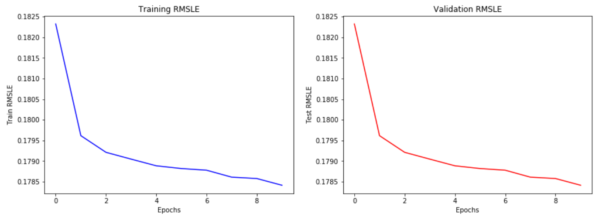

Fig 11.1: RMSLE graph for each epoch.

# Model Deployment

As the Server-Side and Client-Side design is completed, we should include preprocessing and prediction steps in ‘predictor_api.py’ file. To do so, first methods (Word2vec, PCA, Label Encoder and Scaler) and models (Machine learning and Deep learning) should be exported, in order to transform them on incoming data. Upon our research, we found that Python provides a module called pickle, which serializes objects to file and loads it into a program whenever necessary.

Serialization refers to the process of converting an object or method to a byte stream that can be stored on disk. Later this stream can be retrieved and de-serialized back to a python object [32]. Pickle is useful when you want to store preprocessed data and machine learning algorithms, as they can be used to make new predictions later. As our dataset has more than 1.4 million records, pickling objects saved us a lot of time. Fig. 12.1 show python code to save models to pickle file.

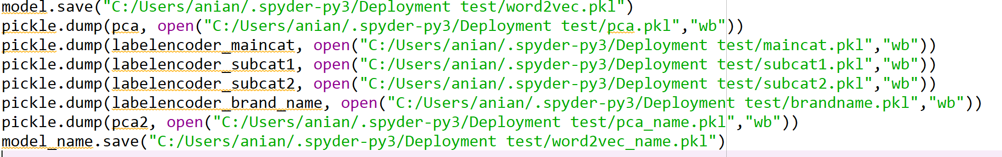

Fig. 12.1. Python code to save Models to Pickle files

Now these pickles files should be loaded in ‘predictor_api.py’ file to transform incoming data using preprocessing techniques in order to predict price. Figure 12.2 shows the code snippet to load pickle files.

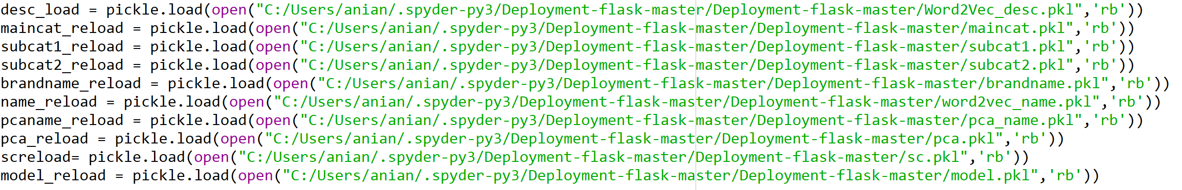

Fig. 12.2. Python code to load Pickle files

Once these pickle files are loaded, price_output method takes a single row of data given by user and returns price. Fig. 12.3 and 12.4 show parts of method price_output.

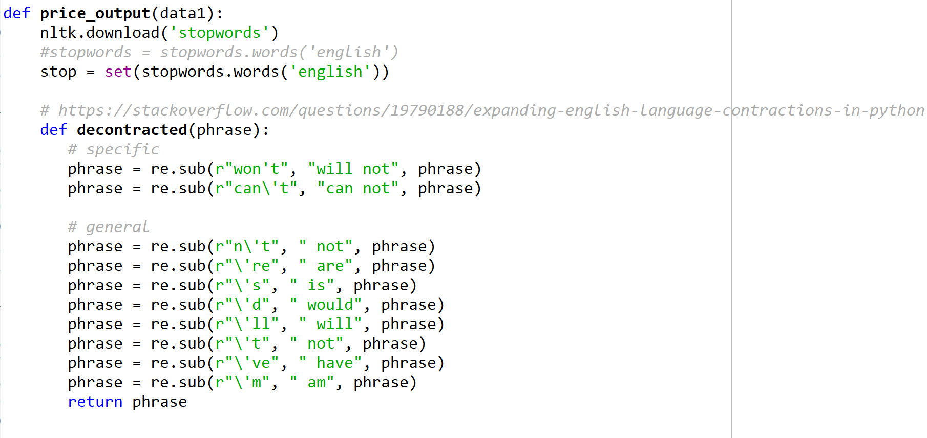

Fig. 12.3. Code Snippet of price_output Part -1

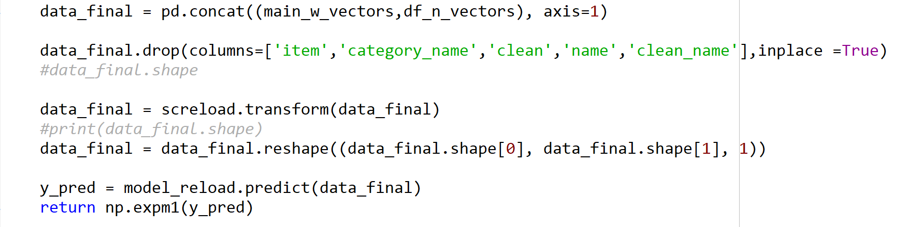

Fig. 12.4. Code Snippet of price_output Part -2

Python modules support importing methods from one file to another. To reuse the code, price_output method was imported from ‘predictor_api.py’ file to ‘predictor_app.py’ (same name), which has flask code. Fig. 12.5 shows code snippet of the predict method. This method retrieves the form values, converts into a data frame and then it will send that as an argument to price_output method.

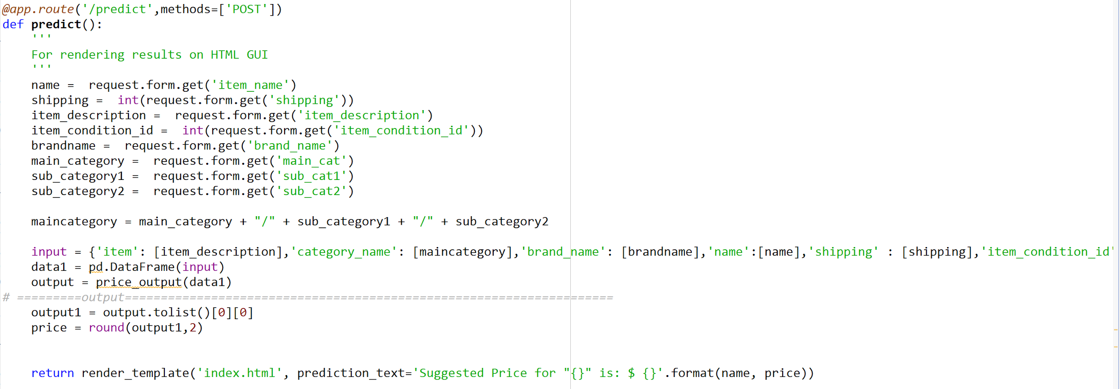

Fig. 12.5. Code Snippet of predict method

Finally, this model is deployed on Amazon EC2 cloud server. It is a web service that provides secure, resizable computing capacity in the cloud [33]. EC2 is integrated with other amazon services like Simple Storage Service (S3), [Relational Database Service](https://aws.amazon.com/rds/) (RDS) to provide secure solution for computing and processing. It also changes the economics of computing by allowing to pay only for capacity used.

After creating EC2 virtual server in AWS management console, an Ubuntu cloud instance is created to deploy a model and create an application programming interface (API) out of it. Fig. 12.6 shows the ubuntu cloud server selected for creating the instance.

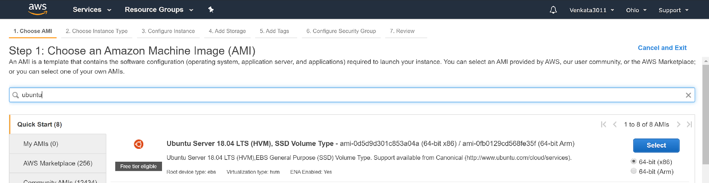

Fig. 12.6. Selected Ubuntu Cloud Server

After selecting Amazon machine image (ubuntu cloud server), pem file [34] will be downloaded. Using pem file, a new private key file can be generated, which helps us to interact with the Linux environment. Fig. 12.7 shows process of downloading pem file. In the end, a new instance is created. Fig. 12.8 shows the new EC2 instance.

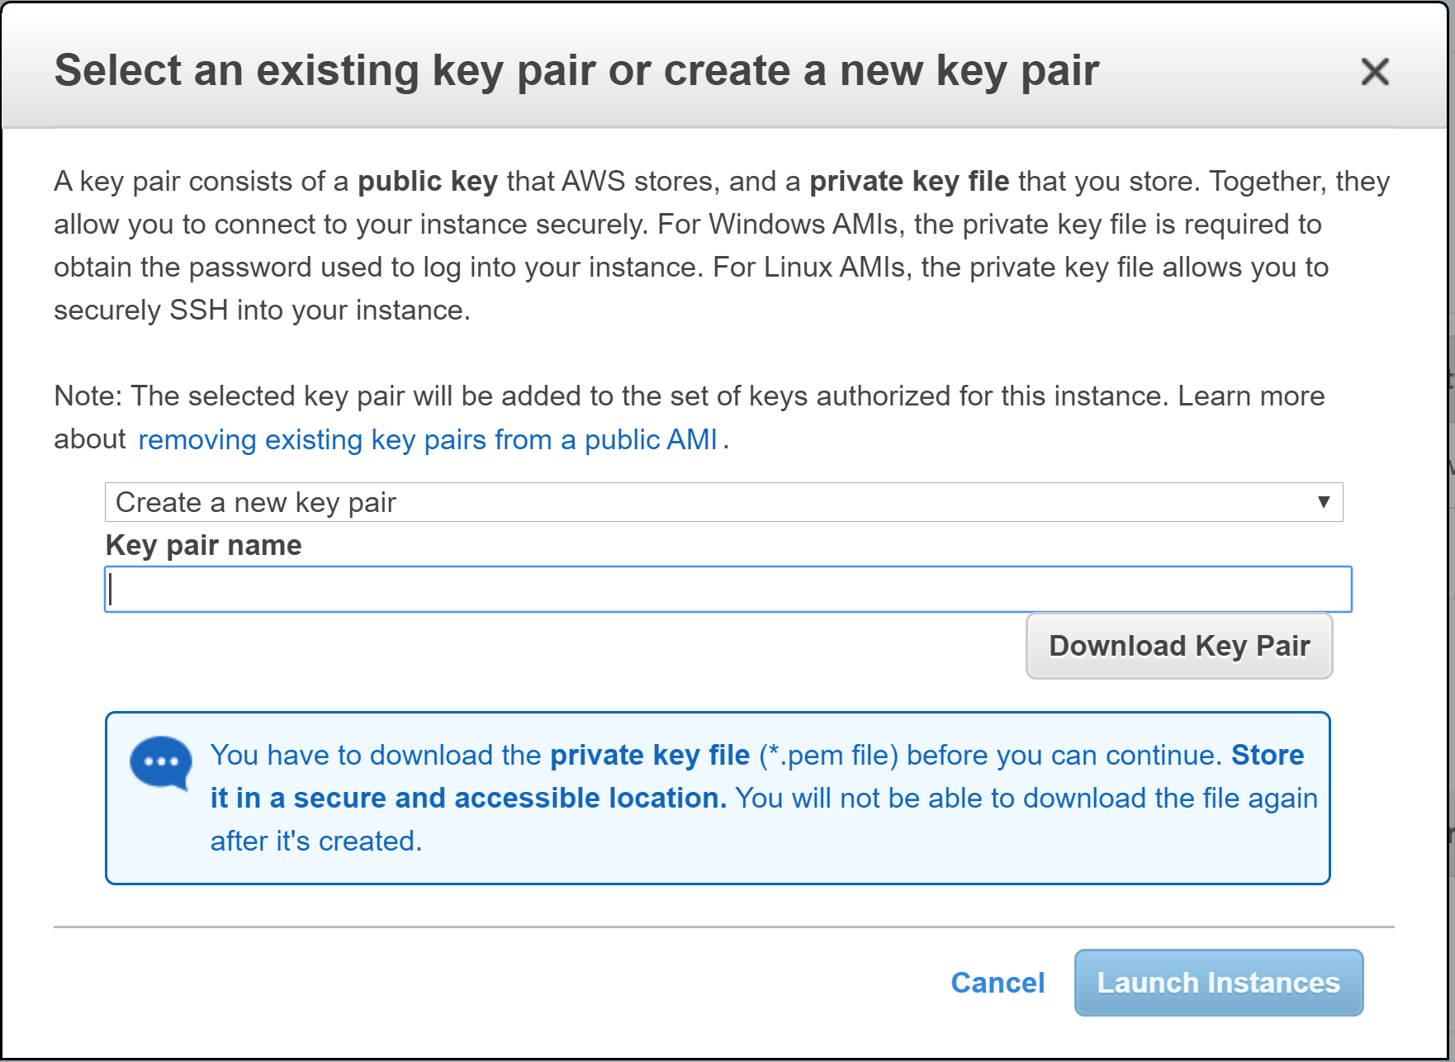

Fig. 12.7. Process to download pem file

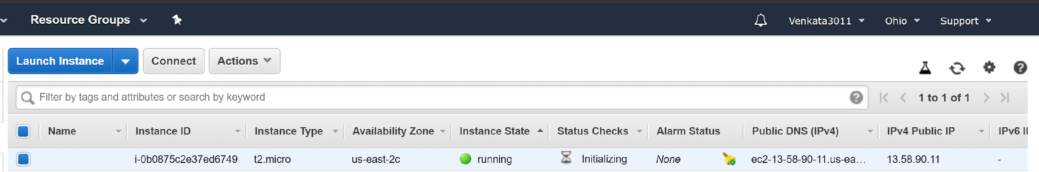

Fig. 12.8. Instance Created

We used tools to interact with this instance and deploy our model.

* Windows Secure Copy (WinSCP)
* PuTTY gen
* PuTTY.

PuTTY gen is a tool for generating public and private SSH keys [35]. PuTTY Key Generator tool is shown in figure 12.9. After loading pem file, it will download a PuTTY private key file.

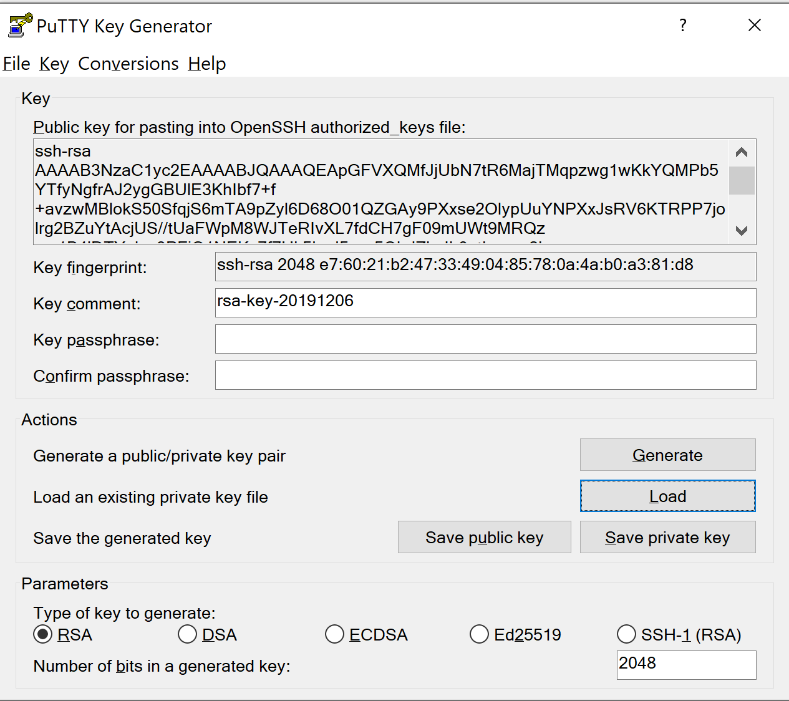

Fig. 12.9. PuTTY Key Generator

Windows Secure Copy (WinSCP) [36] is a free and open source file transfer protocol for Microsoft windows. Its main function is to secure file transfer between local and remote computer. Using this tool code files can be transferred from local computer to EC2 instance. Figure 12.10 show the WinSCP interface. After uploading the private key file (generated from PuTTYgen) under advanced option, we can access the ubuntu folder, where all the required files can be dropped. In figure 12.11, left half is file structure of local computer and right half is the file structure of ubuntu folder after loading all the code files.

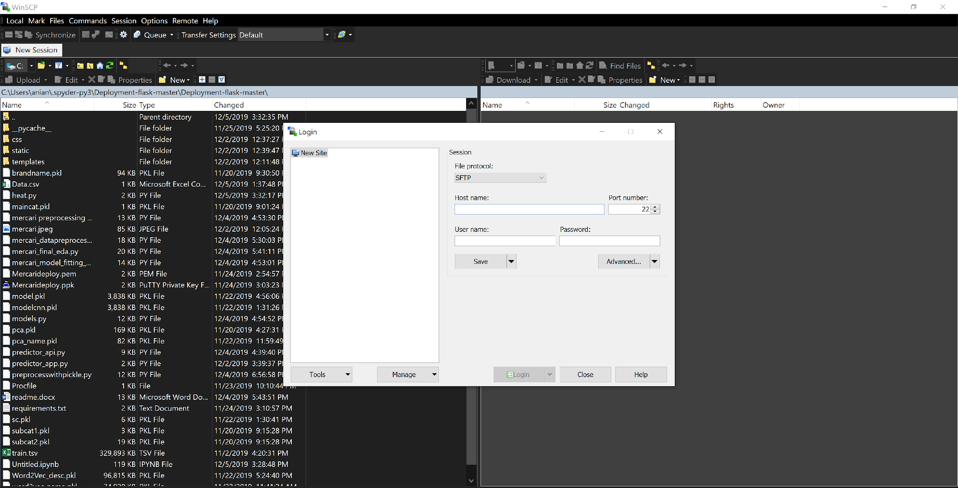

Fig. 12.10. WinSCP Interface

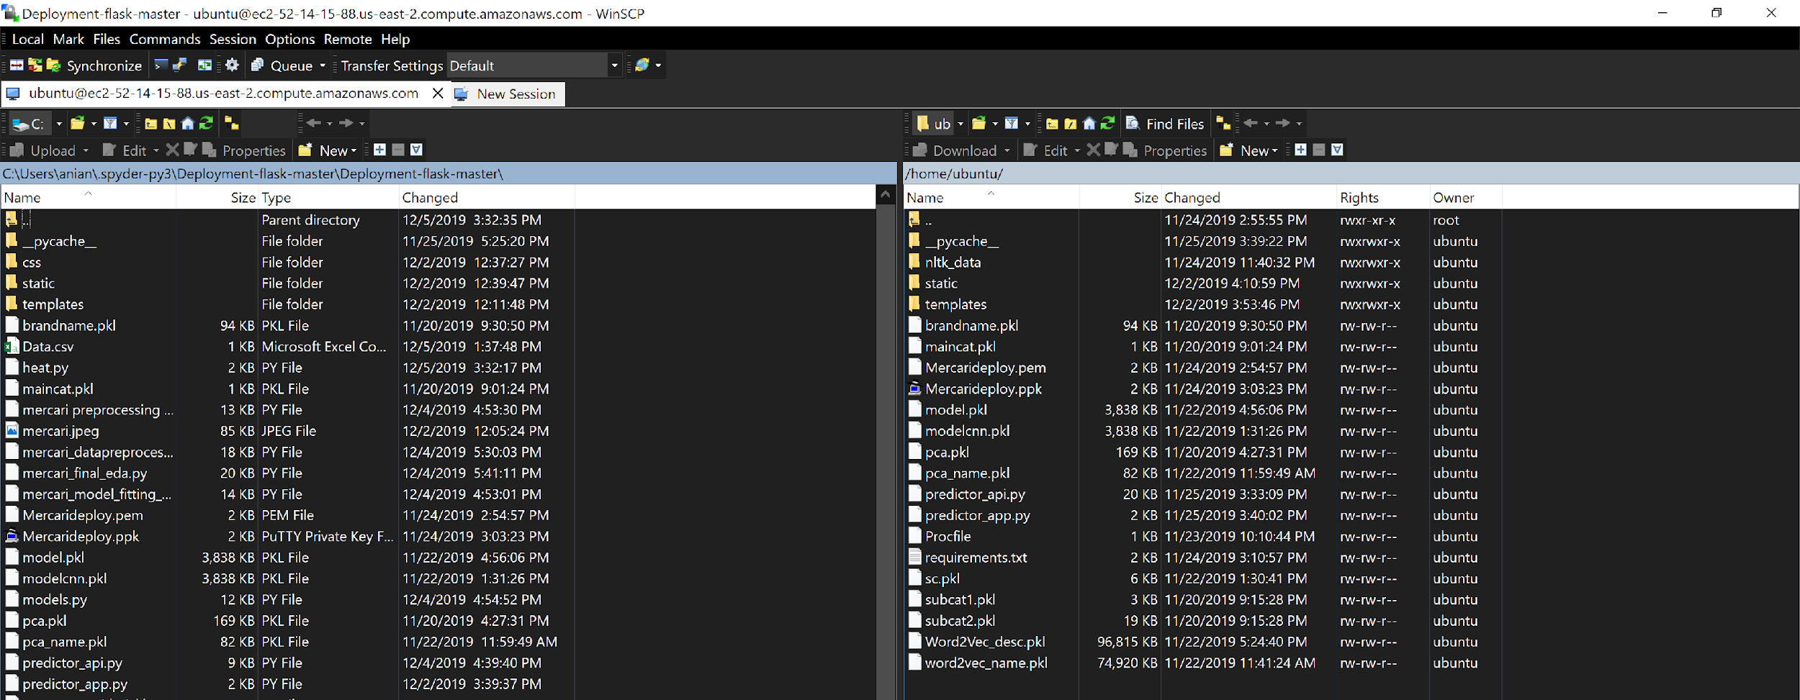

Fig. 12.11. File Structure in Local Computer and Ubuntu Server

PuTTY is a terminal emulator application which can act as a client SSH (Secure Shell) [37]. It can be used for remote access to another computer or server. By uploading the private key file (generated from putty gen) in SSH authentication as shown in figure 12.12, we can run python files in ubuntu server.

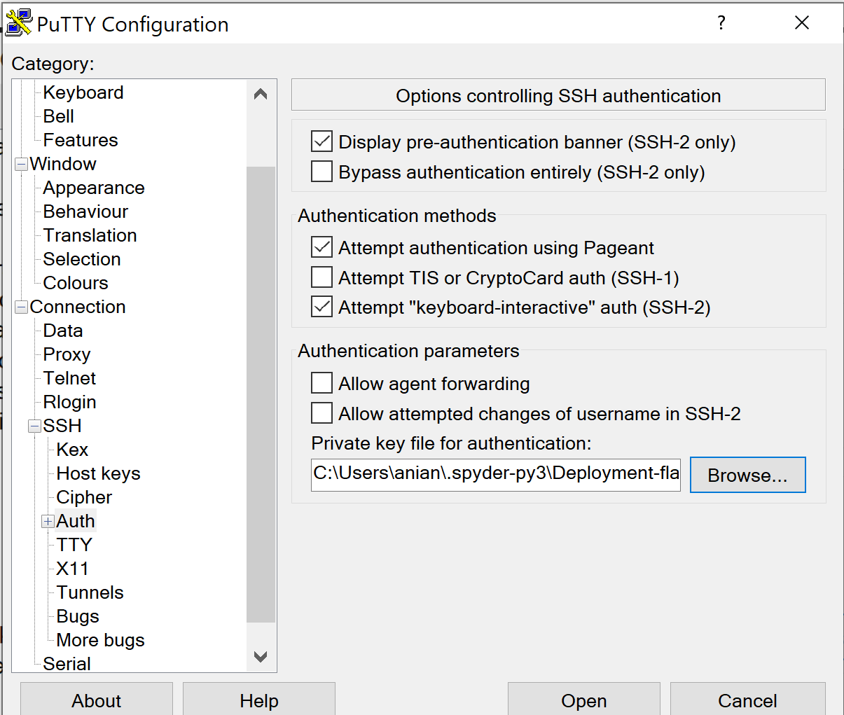

Fig. 12.12. Configuring PuTTY

Once these python files are instantiated, by opening the DNS of EC2 instance, we can see the user interface as shown in figure 12.13.



Fig. 12.13. User Interface

As shown in figure 12.14 once a user clicks on Price Fairly, a form pops up. Here, we fill the details of the product/item to be sold. After submitting the form, suggested price will be shown as the output. Figure 12.15 shows the output of predicted price of the item.



Fig. 12.14. Pop-up form



Fig. 12.15. Output with price suggestion

# High Performance Computing (HPC)

As our data contains more than 1.4 million records, speed is a huge player in preprocessing and modeling the data. With our existing non-distributed IDE, for example Spyder, it takes hours to iterate over the data. To address the issues in workloads and resources, we adapted HPC approach. First let’s go through the actual definition and then we will discuss more about the tools and cloud platforms we used to resolve our issues [38].

HPC resources allow data scientists to work on the data faster and treat problems. They are superior to standard computing resources. They have powerful processors, more storage and memory when compared with local computing resources. These systems are efficient and convenient to use [39].

* **Google Colab:** Google provides free cloud service with Jupyter notebook interface with free GPU (Graphics Processing Unit) and TPU(Tensor Processing Unit) [40]. By clicking on upload option, which is to the left side of the Colab interface(figure 13.1), we can upload the files.

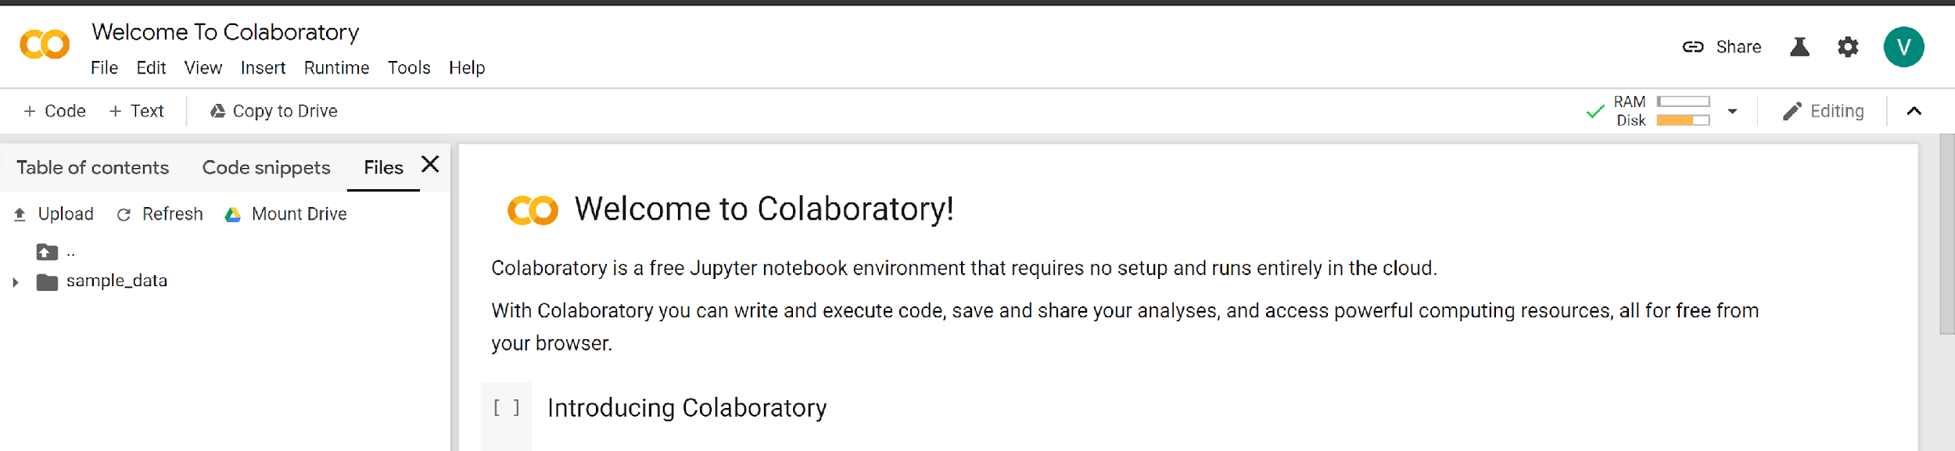

Fig. 13.1. Google Colab Interface

By default, runtime in Google Colab is None. It can be changed to GPU and TPU as required. Due to the limited disk space and RAM, it takes hours to train our data in Colab with many runtime issues. Hence, we decided to train our model in Google cloud platform.

* **Google Cloud Platform (GCP):** GCP helps developers and data scientists to build and run superior Machine learning models on large datasets. Scaling central processing unit (CPU), Random Access memory (RAM) and GPU is one of the characteristics of GCP. It also offers a special feature called Hyper Parameter Tuning to get better and faster results [41]. Google AI platform has a collection of frameworks which include Tensorflow, Keras, XGBoost and Scikit-learn [42]. Artificial intelligence (AI) notebooks allows to create and manage virtual machines. Figure 13.2 show the instance created with 16vCPU and 104 GB memory. In addition to these two NVIDIA Tesla K80, GPU are also used. This VM instance has a Jupyter lab platform which enables us to run Notebooks. We uploaded the preprocessed data in the form of pickle files to AI Notebooks and trained our model.

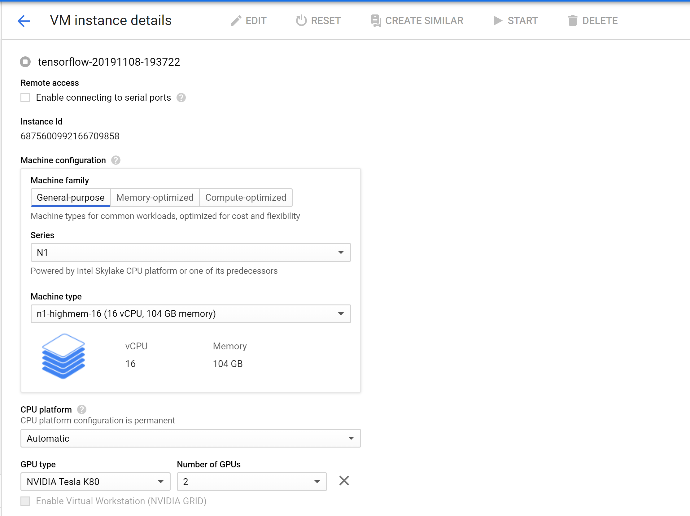

Fig. 13.2. Google Cloud Instance

# Documentation

Below are the insights and conclusion from our research paper [43], which was the precursor study for this project. The conclusion stated that the future belongs to online retailers who embrace an agile and automated dynamic pricing scheme. Moreover, ML-based techniques are slated to pave way to prescriptive and AI-based pricing with increased personalization, along with customer interaction [44]. Custom algorithms tailored to business needs are the need of the hour. Errorless data collection, advanced data analytics and an adjustable pricing framework constitute the fundamental steps in building a rounded prediction engine to defeat the competition. Sundry tools such as [Competera](https://competera.net/competitive-data), [Wiser (QuadAnalytics](https://www.wiser.com/)), [Market Track](https://markettrack.com/ecommerce-pricing) and [Upstream Commerce](http://upstreamcommerce.com/) are available commercially [44]. Unsurprisingly, Supervised, unsupervised, semi-supervised and reinforcement learning have been employed for algorithmic price prediction from time to time. Clustering and association reveal hidden groups, patterns and anomalies. Q-learning based reinforcement models are ideal for an unrealistic stationary scenario, whereas XGBoost is capable of efficiently predicting prices in a volatile environment. Ensemble models combine decisions from two or more models and accomplish higher performance with lower noise, bias and variance [45]. Random forest with bagging produced promising results in a data-rich environment, for price optimization and demand estimation of new products [45]. Neural network models such as Recurrent neural network (RNN) and Convoluted Neural Network(CNN) are used to build bigger and deeper models that need a sizable volume of data for training. CNN is faster than RNN. Deep learning, with its innate capacity to extract high-level features from big data and significantly higher performance, has proven to be an efficient and viable method for algorithmic price prediction, albeit the downside of intensive computation, low interpretability and hardware dependency [46].

The current report is the project documentation. Below figure 14.1 shows the major sections covered in the documentation.

|  |
| --- |
| **SECTIONS IN THE DOCUMENTATION** |
| Project Description |
| Requirements |
| KDD |
| Feature Engineering |
| Data Transformation |
| High Level Architecture Design |
| Data Flow Diagram & Component Level Design |
| Sequence or Workflow |
| Data Science Algorithms & Features Used |
| Traditional algorithms & Deep learning |
| Interfaces RESTFul & Server Side Design |
| Client Side Design |
| Testing (Data Validation / nFold) |
| Model Deployment |
| HPC |
| Documentation |
| Design Patterns Used |
| AutoML or Serverless AI |
| Data Engineering |
| Active Learning or Feedback loop |
| Interpretability of the Model |

Fig 14.1. Sections in Document

# Design Patterns Used

Design Patterns in Machine learning projects are reusable computational patterns representing best practices for similar problems [47]. This can be divided into 3 phases as shown in 15.1, 15.2 and 15.3.

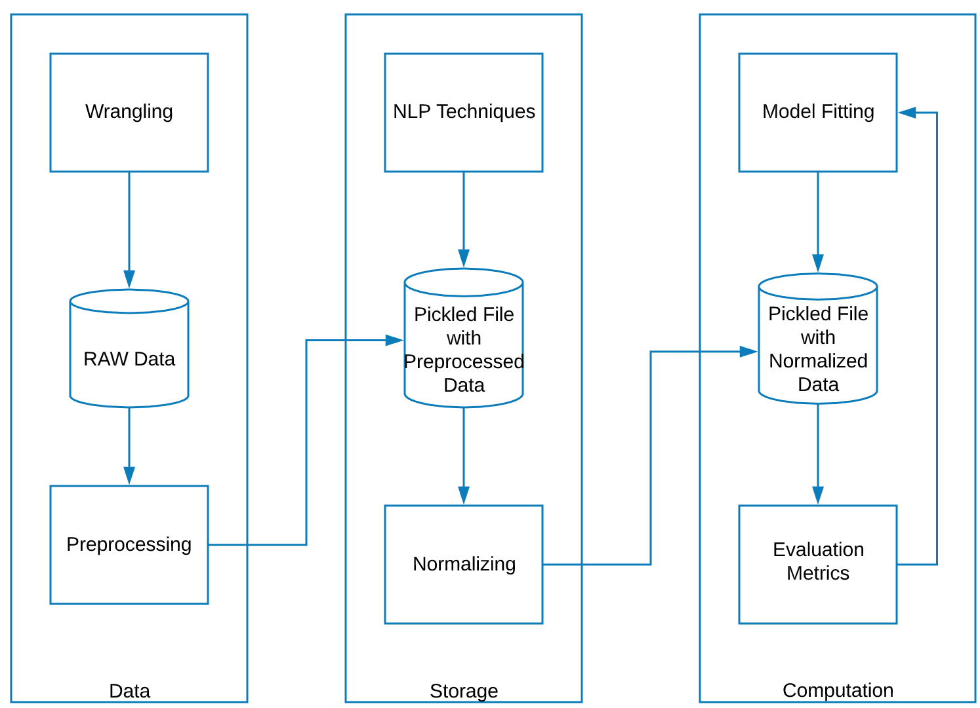

Fig 15.1: Build phase

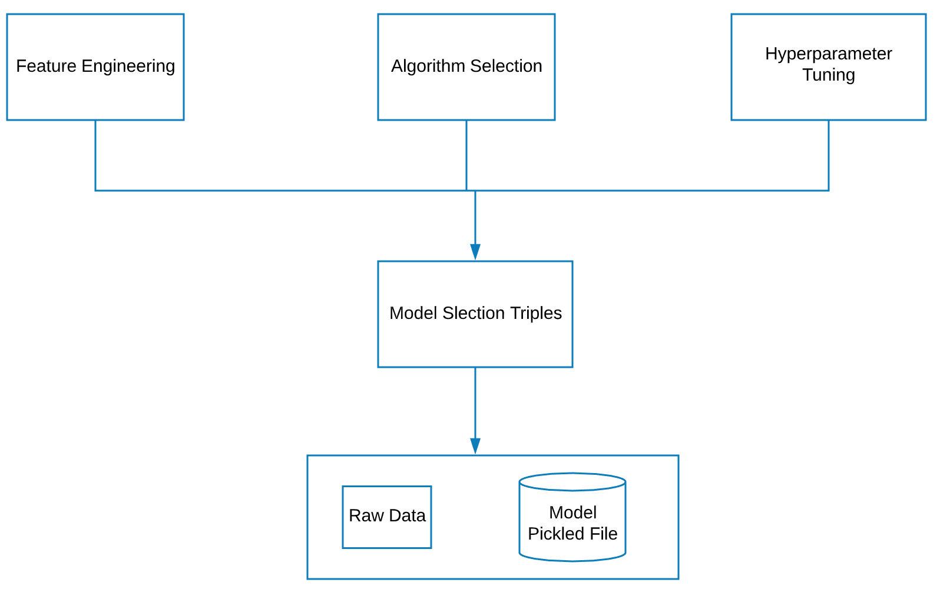

Fig 15.2 Model Selection

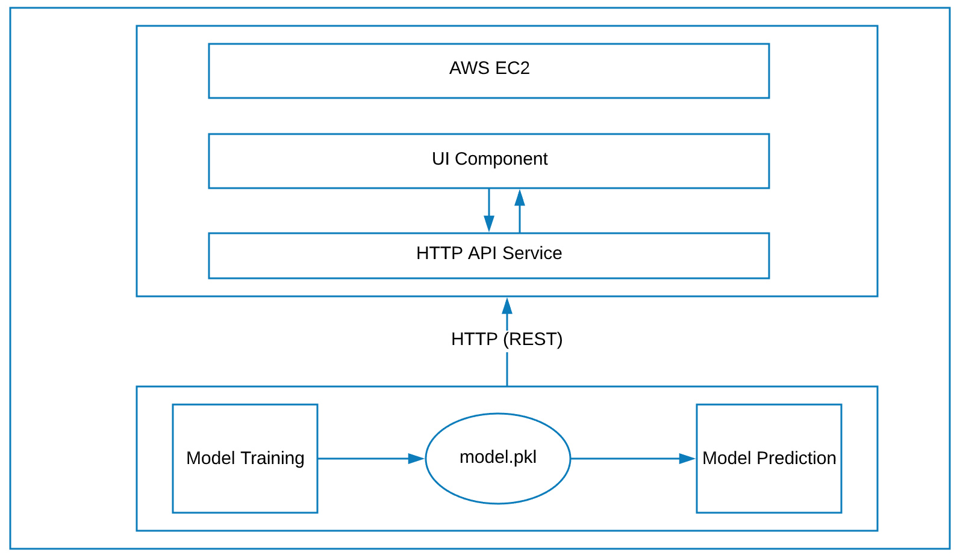

Fig 15.3 Deploy phase

# AutoML or Serverless AI

**Auto ML:** We attempted to use the H20 platform and explored the Auto ML on this dataset. We could not dig any further due to time constraint. But this is a part of our future work and we would continue exploring different viable options. Here is a glimpse of our Auto ML venture.

We chose the H20 platform. The install was painless as it had a good interface, similar to Jupyter notebooks. It had libraries similar to Scikit learn. There was an Auto ml function that automates the process of building large models. It was a simple code that provided a list of models best suited for the data with accuracy details.

**Step 1:** Pip Install H20 in Google colab.

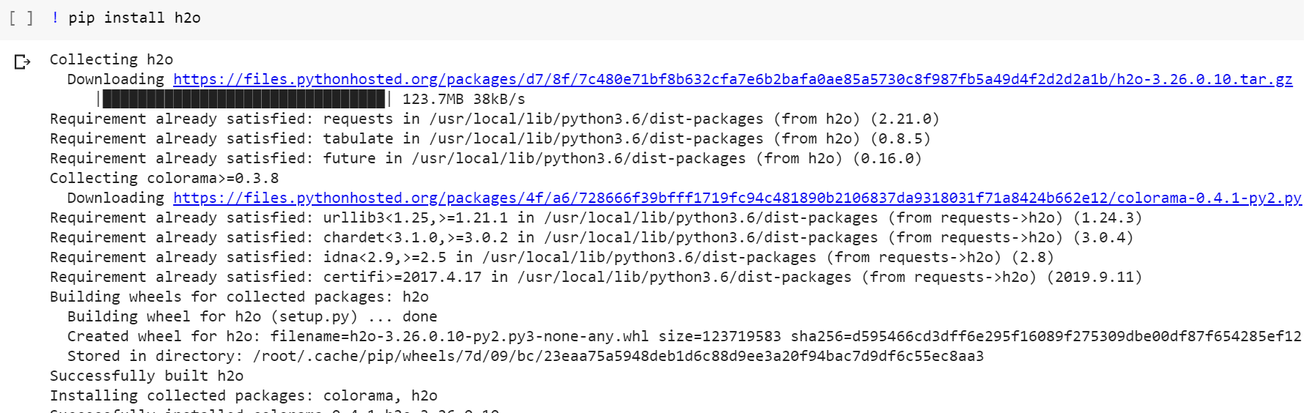

Fig. 16.1 Step 1

**Step 2:** Import required packages.

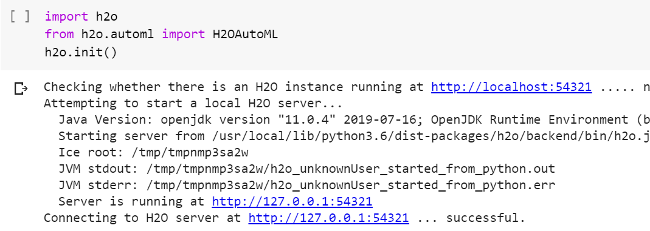

Fig. 16.2 Step 2

**Step 3:** After initial pre-processing, we fitted the model with 2 lines of code.

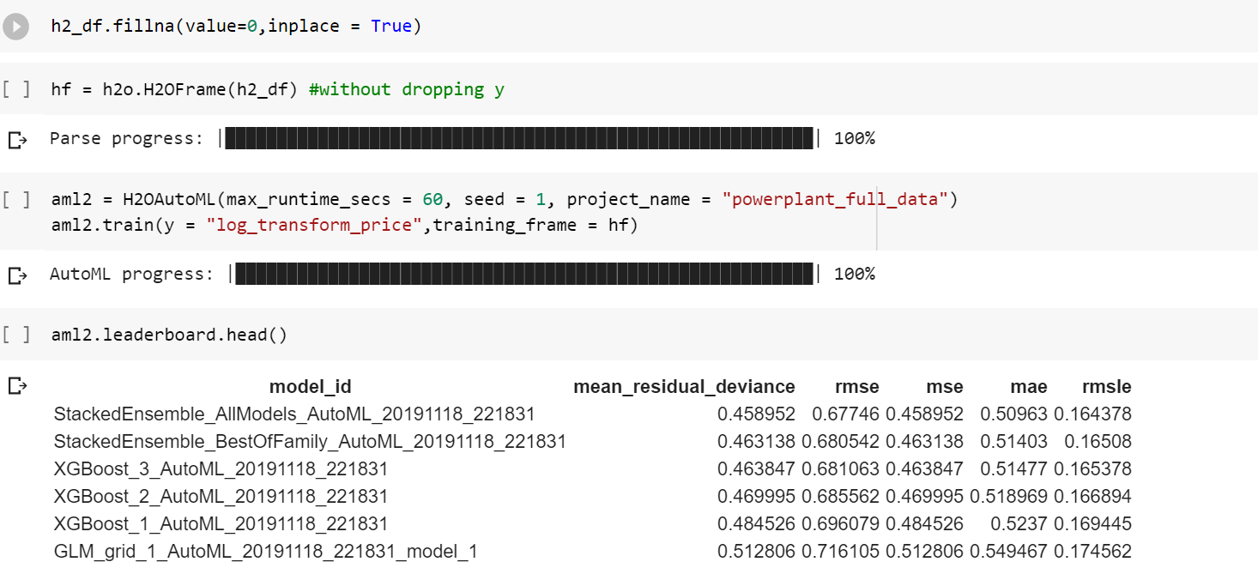

Fig. 16.1 Step 1

# Data Engineering

Figure 17.1 highlights the steps in data engineering [48].

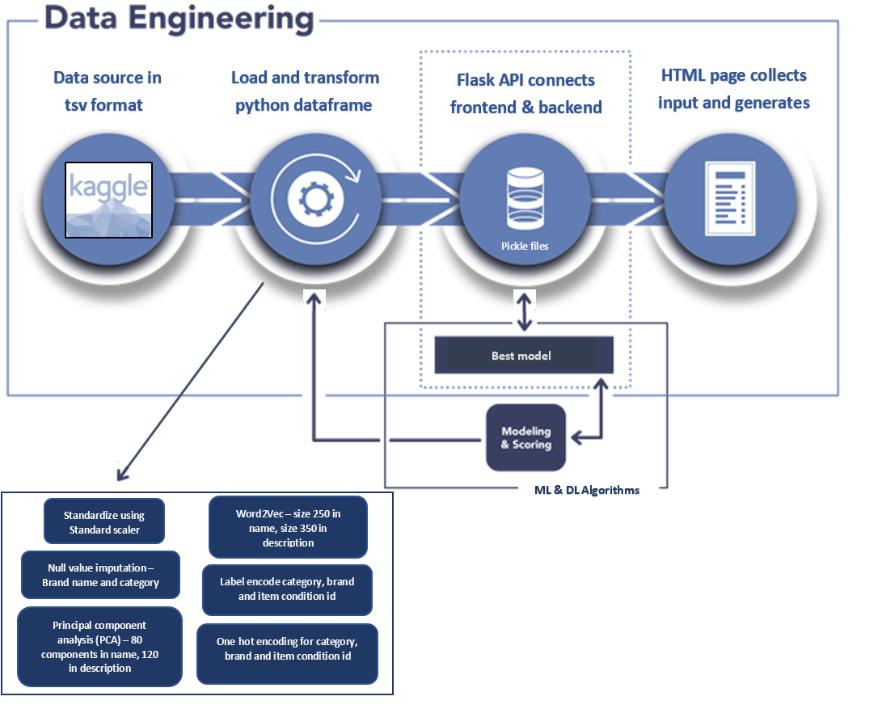

Fig 17.1: Data engineering [48]

* Data from the immutable data source which is Kaggle was extracted using a simple download. The file in **tsv format** was decompressed and loaded as input file to Google colaboratory that provided an interface to create the python notebook.
* A number of Natural language processing approaches such as term frequency - inverse document frequency (TF-IDF) and Word2Vec were used to transform data and decipher the priority of words in the corpus. Data transformation enabled the tokenization of text, vectorization and word embedding. Word2Vec size was 250 for name and 350 for item description.
* Most prices were on the lower side and the target parameter had to be transformed to encapsulate the relevant range, eliminating any outliers. Price was converted into logarithmic format as it was right-skewed.
* Standardization was performed using Standard scaler such that mean is zero and standard deviation is one [49].
* The dimensions were limited using the dimensionality reduction technique widely known as Principal component analysis (PCA). 120 components from description and 80 components from name were chosen using this technique that captured 90% variance in the data and reduced noise.
* Label encoder was used to transform category and brand name, which were categorical features, into a numerical format.
* Null values were imputed for nearly 14% of the data (more than 87,000 from approximately 600,000 null values).
* The transformed data was used for model fitting. Various files in pickle format with model was provided using flask, in order to access the same using an html page customized using CSS.
* The page takes in the input, entered as text or selected from drop boxes. Thereafter, it uses the model to find the predicted price and returns the result to the frontend page. The result is finally displayed as a price suggestion to the user.

# Active Learning or Feedback loop

Active learning is a special type of machine learning where the ML model will query the human user/operator during the learning or training process. It aims to resolve ambiguity or absence of labels of training samples.

Active learning is similar to semi-supervised learning but explores the known aspects of data which the model is not aware of. This is a very useful approach when there is sparse data or it is expensive to label the new data.

For our project, we have historical data available from website with similar listings and can download updated real-time data from website, along with the consists of labels. Hence, active learning is not a mandate in our case as most of the data obtained is labeled. Though the data is easily available, we need to verify the truthfulness of the data because in some cases the items sold can be a fake in the Mercari’s website. But it is not easy for a human or machine to interpret those false products and it falls under anomaly detection. In case of optimal price prediction as well as suggestion, we need to depend on the values provided as human labeling is cumbersome and hard to verify.

Feedback loop refers to the process by which an ML model’s predicted outputs are reused to train new versions of the model [50]. In other words, the feedback loop is also called reinforcement learning as machines makes mistakes and learns from the same on its own. However, humans can help resolve the ambiguity in the results and provide valuable feedback. The feedback loop ensures that the results of the ML model don’t stagnate with ambiguity and learns continuously, otherwise known as online learning.

Integrating feedback from human interpreters into the model is important for improving user experience[50]. Subsequently, it trickles down to the fulfillment of business objectives and improves the revenue. Once our website is launched and open sourced, we would consider implementing feedback in our ML model.

# Interpretability of the Model

The initial research of academic approaches and existing research culminated in the submission of an IEEE survey paper that rightly served as a precursor study of the algorithms and techniques [43]. We perused nearly 36 sources to determine the ideal path to move forward and create a seamless design. Our team performed an elaborate exploratory study (EDA) and pre-processing using natural language processing (NLP) and other quintessential packages in python such as Sklearn. Data transformation and validation greatly improved the efficiency of our model as we imputed nearly 14% of the null values. Features and the target underwent a great deal of data munging before they were deemed fit for the model input phase. Features are item attributes such as name, item description, category name, brand name, item condition id and shipping, whereas the target is unsurprisingly the price. The target parameter was right-skewed as most prices were on the lower side. It was converted to logarithmic format to encapsulate the relevant range without the outliers. Additionally, vital data statistics supplemented the features in the model ingestion phase due to their succinct representation of the data. Thereafter, we contemplated, executed and compared algorithmic approaches. Traditional machine learning approaches were Extreme gradient boosting (XGBoost), Decision trees, Linear regression with gradient descent, Support Vector Regressor (SVR) and the ensemble method of Random forest, with the final method fairing best, based on the least error value. Deep learning approaches were multilayer perceptron (MLP), Long-short term memory (LSTM) and Convolution neural network (CNN or ConvNet), out of which CNN emerged the winner with the least error value. It outperformed Random forest from traditional machine learning. Root mean squared logarithmic error (RMSLE) was the robust error metric that drastically scaled-down sensitivity to outliers [32]. The outcome was an optimal model harnessed from CNN, with least error and reliable results. Post deployment using flask interface in AWS EC2 cloud platform, the prediction tool was launched successfully. The HTML page was embellished using CSS. It ingests the user input, for example brand name, description, condition, and instantly suggests the price of the product, based on historical data and user input.

The major challenges were related to the size of the dataset. With more than 1.4 million records, it was cumbersome to run the null value imputation. We switched to Tensor Processing unit (TPU) in google Collaboratory. Therefore, we found model fitting computationally intensive and switched to Google cloud platform (GCP) to complete this activity. The deployment phase was an eye-opener as we learned newer tools and alternatives each time we faced a hurdle. End-to-end project, although challenging, was a great learning experience.

In summary, the model uses historical data of similar listings and outputs to train a range of traditional machine learning and deep learning techniques to pick the best model. The winner has the least error. In this case, the robust and fast deep learning technique named CNN faired best with least error, and formed the backend of this prediction engine. The frontend is a html page, customized with CSS and deployed from python code using Flask in Amazon EC2 cloud platform. The interactive page has an initial button with a pop-up form that collects user input in the form of text or drop box options. Users provide description, category, brand name, shipping type and item condition and submit the form. The output is a one-line result with the suggested price of the product in dollars.

# References

1. About the author(s) Arnau Bages-Amat is a partner in McKinsey’s Brussels office. (n.d.). What really matters in B2B dynamic pricing. Retrieved from [https://www.mckinsey.com/business-functions/marketing-and-sales/our-insights/what-really-matters-in-b2b-dynamic-pricing.](https://www.mckinsey.com/business-functions/marketing-and-sales/our-insights/what-really-matters-in-b2b-dynamic-pricing)
2. What is the CRISP-DM methodology? (n.d.). Retrieved from <https://www.sv-europe.com/crisp-dm-methodology>/.
3. Javier. (2018, September 24). How Machine Learning is reshaping Price Optimization. Retrieved from <https://tryolabs.com/blog/price-optimization-machine-learning/>.
4. Boer, A. V. den. (2015, April 14). Dynamic pricing and learning: Historical origins, current research, and new directions. Retrieved from <https://www.sciencedirect.com/science/article/pii/S1876735415000021>.
5. About the author(s) Gadi BenMark is an associate partner in McKinsey’s New York office. (n.d.). How retailers can drive profitable growth through dynamic pricing. Retrieved from <https://www.mckinsey.com/industries/retail/our-insights/how-retailers-can-drive-profitable-growth-through-dynamic-pricing>.
6. Tanir, B. (2019, April 15). 5 Smart Pricing Strategies to Help You Beat Your Competitors: X-Cart. Retrieved from <https://www.x-cart.com/blog/pricing-tactics.html>.
7. Ved, M. (2018, July 13). Dynamic Pricing in E-Commerce. Retrieved from <https://medium.com/@mehulved1503/dynamic-pricing-in-e-commerce-3f0a066a3728>.
8. Hirano, T. (2016, March 2). Japan's C2C marketplace app Mercari secures $74 million series D round. Retrieved from <https://thebridge.jp/en/2016/03/mercari-series-d-funding>.
9. Engelmann, J., & Richter, F. (2018, June 19). Infographic: Unicorn startup Mercari is Japan's most popular resale app. Retrieved from <https://www.statista.com/chart/14330/mercari-japans-most-popular-resale-app/>.
10. Japanese unicorn Mercari sparkles in market debut. (2018, June 19). Retrieved from <https://www.afr.com/technology/japanese-unicorn-mercari-sparkles-in-market-debut-20180619-h11lie>.
11. Mercari: The Selling App by Mercari, Inc. android app ranking & stats. (n.d.). Retrieved from <https://www.similarweb.com/app/google-play/com.mercariapp.mercari/statistics#ranking>.
12. Engelmann, J., & Richter, F. (2018, June 19). Infographic: Unicorn startup Mercari is Japan's most popular resale app. Retrieved from <https://www.statista.com/chart/14330/mercari-japans-most-popular-resale-app/.>
13. Smith, C., Smith, C., Disney, Dmr, & Disney. (2019, August 25). 11 Amazing Mercari Facts and Statistics. Retrieved from <https://expandedramblings.com/index.php/mercari-facts-statistics/>.
14. Bhanot, K. (2019, June 7). Different techniques to represent words as vectors (Word Embeddings). Retrieved from <https://towardsdatascience.com/different-techniques-to-represent-words-as-vectors-word-embeddings-3e4b9ab7ceb4>.
15. Principal Component Analysis Tutorial. (n.d.). Retrieved from <https://www.dezyre.com/data-science-in-python-tutorial/principal-component-analysis-tutorial>.
16. Cheplyaka. (2017, December 11). Explained variance in PCA. Retrieved from <https://ro-che.info/articles/2017-12-11-pca-explained-variance>.
17. Koen, S. (2019, March 27). Not yet another article on Machine Learning! Retrieved from <https://towardsdatascience.com/not-yet-another-article-on-machine-learning-e67f8812ba86>.
18. Ray, S., & Business Analytics and Intelligence. (2019, December 3). Essentials of Machine Learning Algorithms (with Python and R Codes). Retrieved from <https://www.analyticsvidhya.com/blog/2017/09/common-machine-learning-algorithms/>.
19. yiu, T. (2019, June 2). Understanding Neural Networks.Retrieved from <https://towardsdatascience.com/understanding-neural-networks-19020b758230>.
20. Kain, N. K. (2019, December 2). Understanding of Multilayer perceptron (MLP). Retrieved from <https://medium.com/@AI_with_Kain/understanding-of-multilayer-perceptron-mlp-8f179c4a135f>.
21. Saha, S. (2018, December 15). A Comprehensive Guide to Convolutional Neural Networks — the ELI5 way. Retrieved from <https://towardsdatascience.com/a-comprehensive-guide-to-convolutional-neural-networks-the-eli5-way-3bd2b1164a53>.
22. Grinberg, M. (n.d.). Designing a RESTful API with Python and Flask. Retrieved from <https://blog.miguelgrinberg.com/post/designing-a-restful-api-with-python-and-flask>.
23. Subramanian, S. (2019, September 7). RESTful Web Services With Python Flask - DZone Integration. Retrieved from <https://dzone.com/articles/restful-web-services-with-python-flask>.
24. Introduction to Flask¶. (n.d.). Retrieved from <https://pymbook.readthedocs.io/en/latest/flask.html>.
25. Chow, J. (2019, July 1). Deploying Models to Flask. Retrieved from <https://towardsdatascience.com/deploying-models-to-flask-fb62155ca2c4>.
26. API¶. (n.d.). Retrieved from <https://flask.palletsprojects.com/en/1.1.x/api/#flask.Flask.route>.
27. Flask – HTTP methods. (n.d.). Retrieved from <https://www.tutorialspoint.com/flask/flask_http_methods.htm>.
28. HTML and CSS. (n.d.). Retrieved from <https://www.w3schools.com>/.
29. Kumar. (n.d.). Types of Cascading Style Sheets (CSS). Retrieved from <https://www.c-sharpcorner.com/UploadFile/e6a884/types-of-css/>.
30. Jj. (2016, March 23). MAE and RMSE - Which Metric is Better? Retrieved from <https://medium.com/human-in-a-machine-world/mae-and-rmse-which-metric-is-better-e60ac3bde13d>
31. Saxena, S. (2019, November 26). RMSE vs RMLSE - What's the Difference? When Should You use Them? Retrieved from <https://medium.com/analytics-vidhya/root-mean-square-log-error-rmse-vs-rmlse-935c6cc1802a>.
32. Python Pickle Tutorial. (n.d.). Retrieved from <https://www.datacamp.com/community/tutorials/pickle-python-tutorial>
33. Daly, D. J., & Daly, D. J. (1987). Economics 2: EC2. Retrieved from <https://aws.amazon.com/ec2/?sc_icampaign=consolesignout_generic_explore_ec2&sc_ichannel=ha&sc_icontent=awssm-1111&sc_iplace=tile&trk=ha_awssm-1111>..
34. What is PEM Format? (n.d.). Retrieved from <https://support.quovadisglobal.com/kb/a37/what-is-pem-format.aspx>.
35. Administering Oracle Event Hub Cloud Service - Dedicated. (2018, December 22). Retrieved from <https://docs.oracle.com/en/cloud/paas/event-hub-cloud/admin-guide/generate-ssh-key-pair-using-puttygen.html.>
36. Free Award-Winning File Manager. (2019, December 5). Retrieved from <https://winscp.net/eng/index.php>.
37. PuTTY tutorial. (n.d.). Retrieved from <https://www.ssh.com/ssh/putty/>.
38. Vasudev, R. (2019, June 7). Why Distributed Deep learning is going to gain paramount importance? Retrieved from <https://towardsdatascience.com/why-distributed-deep-learning-is-going-to-gain-paramount-importance-bd2d83517483>.
39. Why use High Performance Computing? (n.d.). Retrieved from <https://epcced.github.io/hpc-intro/00-why-hpc/?source=post_page-----bd2d83517483---------------------->.
40. Foundation, O. G. (2018, December 8). Central Processing Unit (CPU) vs Graphics Processing Unit (GPU) vs Tensor Processing Unit (TPU). Retrieved from <https://iq.opengenus.org/cpu-vs-gpu-vs-tpu/>.
41. MP, A. (2019, June 17). GCP Essentials - Machine Learning Overview. Retrieved from <https://medium.com/google-cloud/gcp-essentials-machine-learning-overview-bfeba5d800e7>.
42. MSV, J. (2019, April 22). Why You Should Consider Google AI Platform For Your Machine Learning Projects. Retrieved from <https://www.forbes.com/sites/janakirammsv/2019/04/16/why-you-should-consider-google-ai-platform-for-your-machine-learning-projects/#681128c722ab>.
43. Rao, M. R., Thota, V. A. K., Koouri, P., & Puppala, N. (not published, 2019). Survey of Dynamic price Prediction in Modern Retail platforms.A. Galkin, “Strategic Pricing in Retail with Machine Learning,” Medium, 24-Aug-2017. [Online]. Available: <https://blog.statsbot.co/strategic-pricing-d1adcc2e0fd6>. [Accessed: 18-Nov-2019].
44. Juhi, “Simple guide for ensemble learning methods,” Medium, 25-Feb-2019. [Online]. Available: <https://towardsdatascience.com/simple-guide-for-ensemble-learning-methods-d87cc68705a2>. [Accessed: 18-Nov-2019].
45. I. Salian, “SuperVize Me: What’s the Difference Between Supervised, Unsupervised, Semi-Supervised and Reinforcement Learning?,” The Official NVIDIA Blog, 02-Aug-2018. [Online]. Available: <https://blogs.nvidia.com/blog/2018/08/02/supervised-unsupervised-learning/>. [Accessed: 18-Nov-2019].
46. Thapliyal, M. P. (2019, July 9). Advance AI: Machine Learning design patterns. Retrieved from <https://medium.com/mlrecipies/advance-ai-machine-learning-design-patterns-d05397eb2191>.
47. Elder Research, Inc. (n.d.). Data Engineering. Retrieved from <https://www.elderresearch.com/consulting-services/data-engineering>
48. Dorpe, S. V. (2018, December 13). Preprocessing with sklearn: a complete and comprehensive guide. Retrieved from <https://towardsdatascience.com/preprocessing-with-sklearn-a-complete-and-comprehensive-guide-670cb98fcfb9>.
49. Brownlee, J. (2019, November 10). 14 Different Types of Learning in Machine Learning. Retrieved from <https://machinelearningmastery.com/types-of-learning-in-machine-learning/>.
50. Anon, (2019). [online] Available at: <https://www.mercari.com/> [Accessed 8 Dec. 2019]
51. Designlights.org. (2019). Technical Requirements V4.4 - DesignLights Consortium. [online] Available at: <https://www.designlights.org/solid-state-lighting/qualification-requirements/technical-requirements/> [Accessed 8 Dec. 2019].
52. [researchgate.net](http://researchgate.net). (2019). [online] Available at: <https://www.researchgate.net/figure/Steps-in-the-KDD-process_fig1_236373188> [Accessed 8 Dec. 2019].
53. Mercari Price Suggestion Challenge. (n.d.). Retrieved from <https://www.kaggle.com/c/mercari-price-suggestion-challenge/data>.